**Open Source Epitomized Structural Program**

Download the program PDF list from link: <https://wwjl.lanzoum.com/LaiformSourceCode> , Unzip password：*pw20250416*. It consists of 4662 pages and only prints file types cpp, h, txt, and cs. The first, middle, and last pages are as follows，

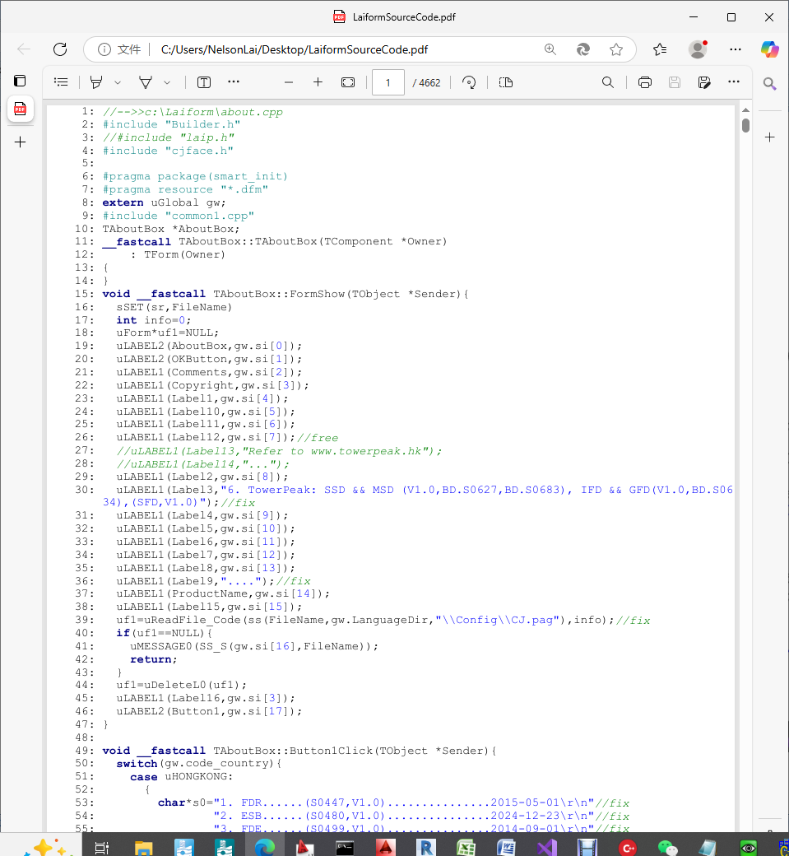

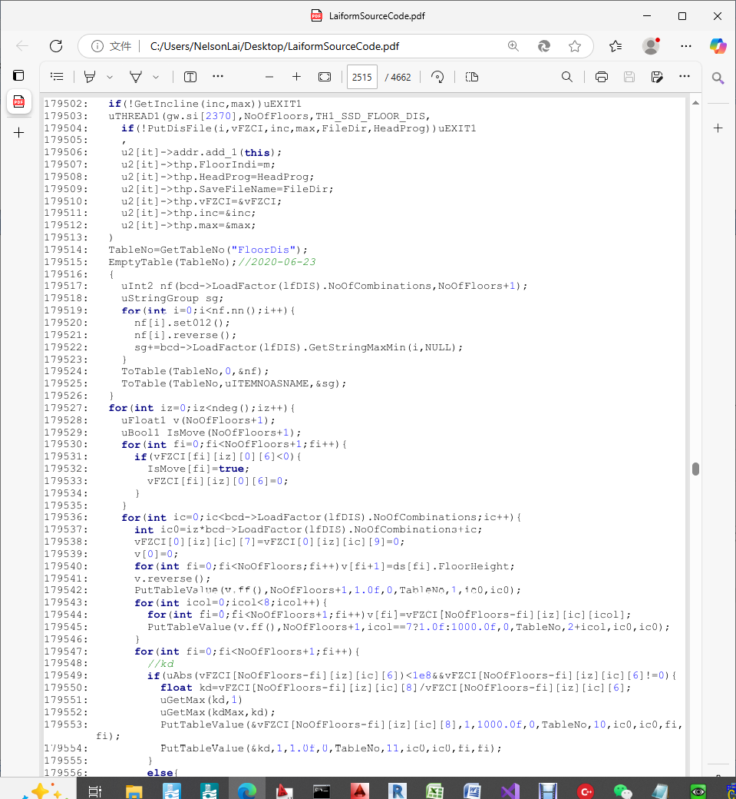

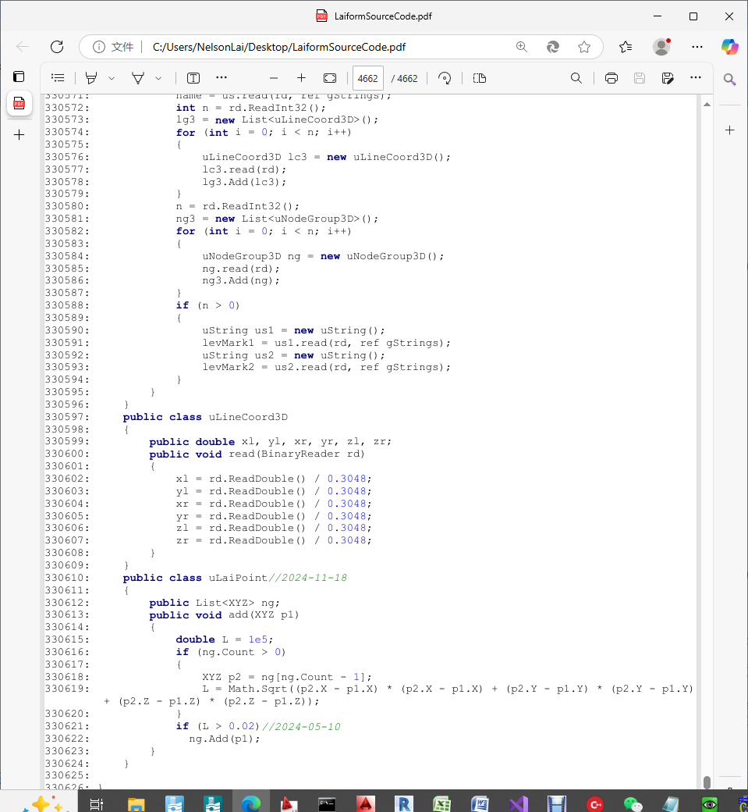

Download the installation program LaiSetup.exe from the link https://wwjl.lanzoum.com/LaiSetup that contains all the source code. Its integrated development environment (IDE) are C++Builder XE5 and Visual Studio 2019. When running the installation program, the following screen will appear：

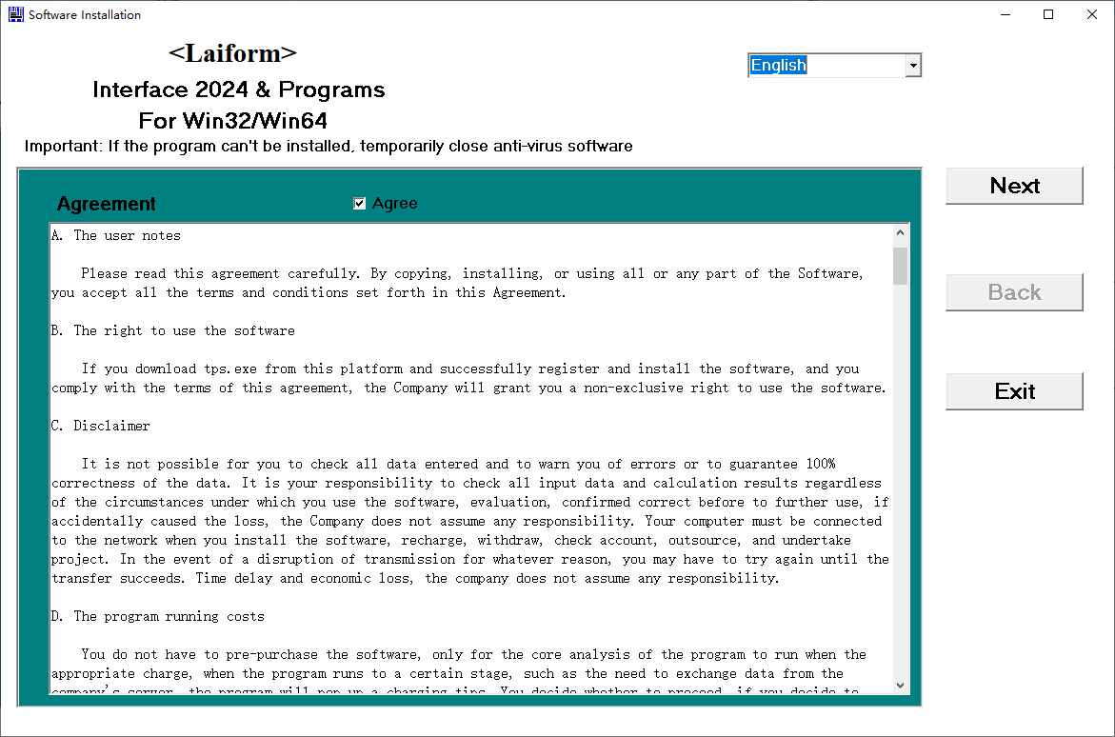

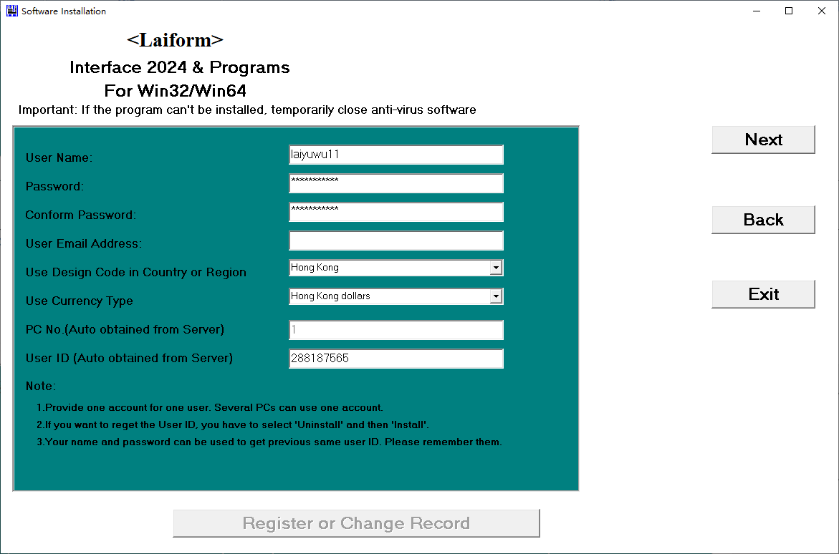

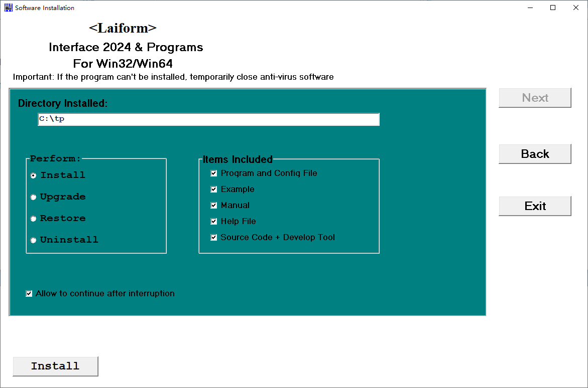

After installation, the program source code will be automatically placed in c: \ Laiform

Open c: \ Laiform \ Laip64.obproj in IDE: C++Builder XE5, as shown below,

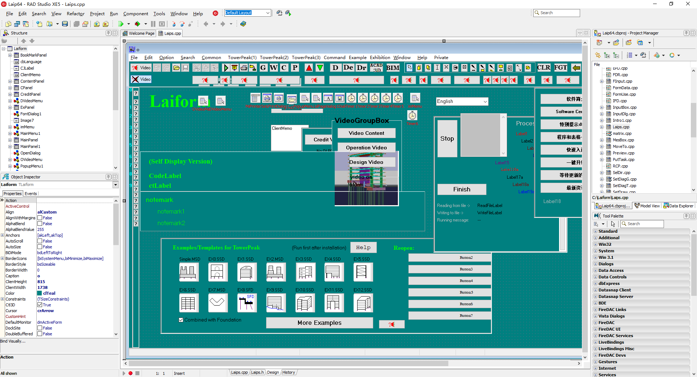

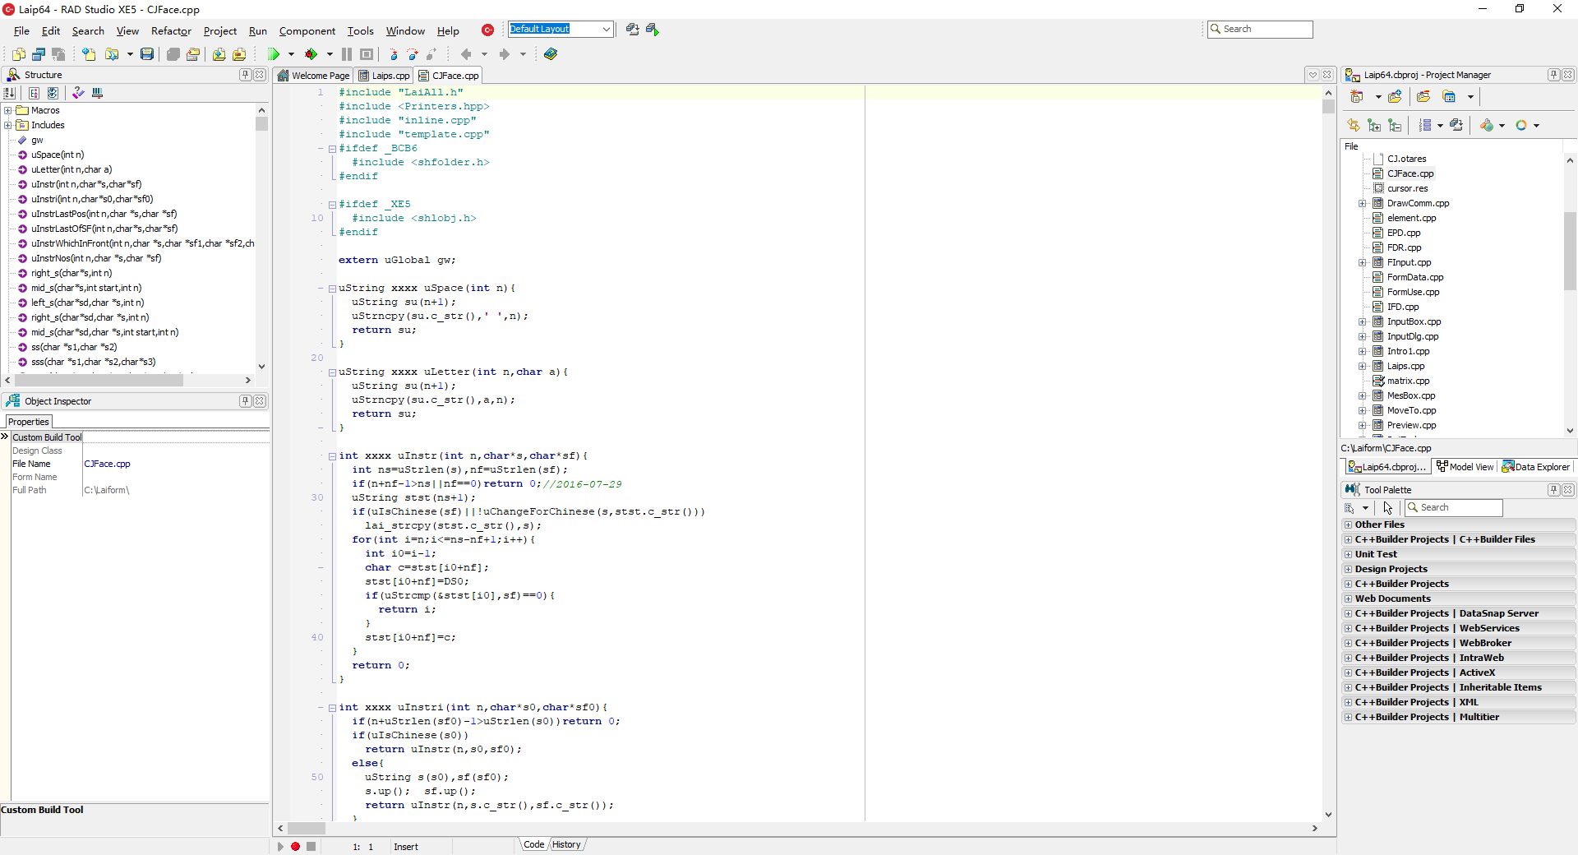

Open c: \ Laiform \ TPtoRevit \ TPtoRevit.sln in IDE:Visual Studio 2019, as shown below,

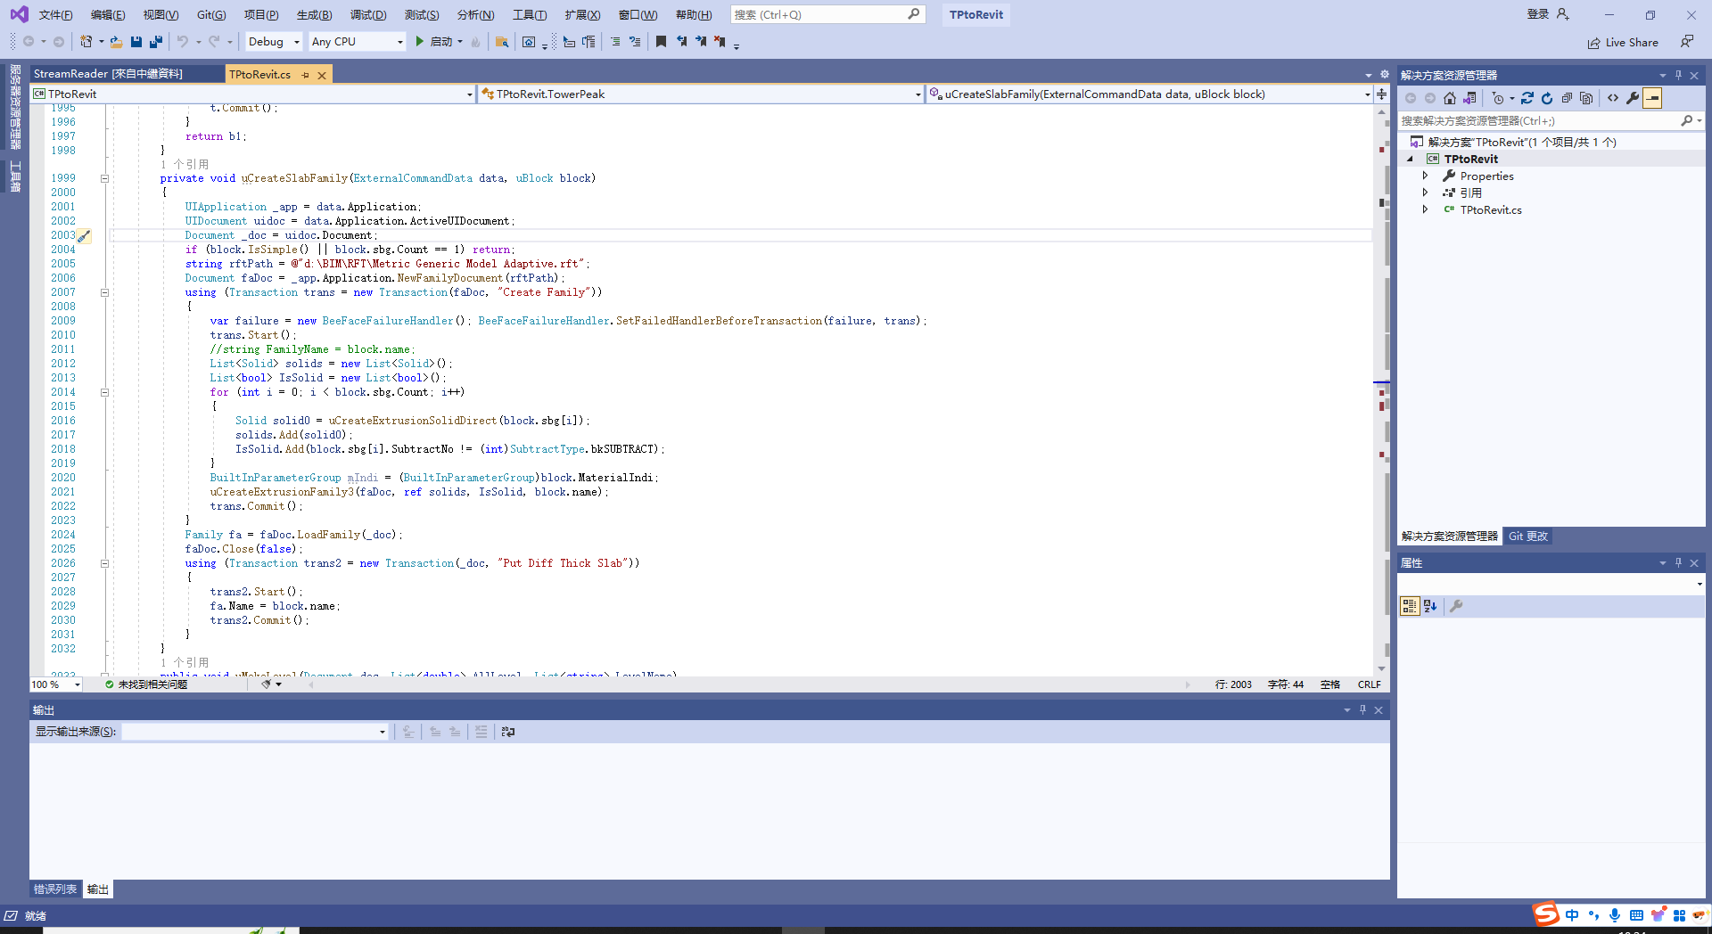

This program includes various subroutines as follows:

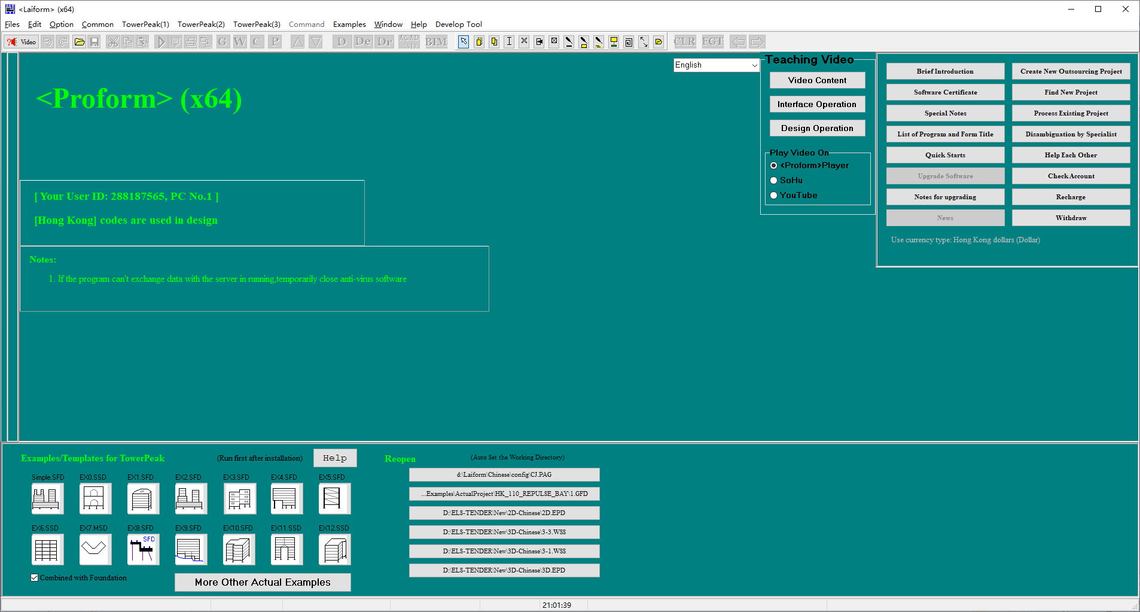

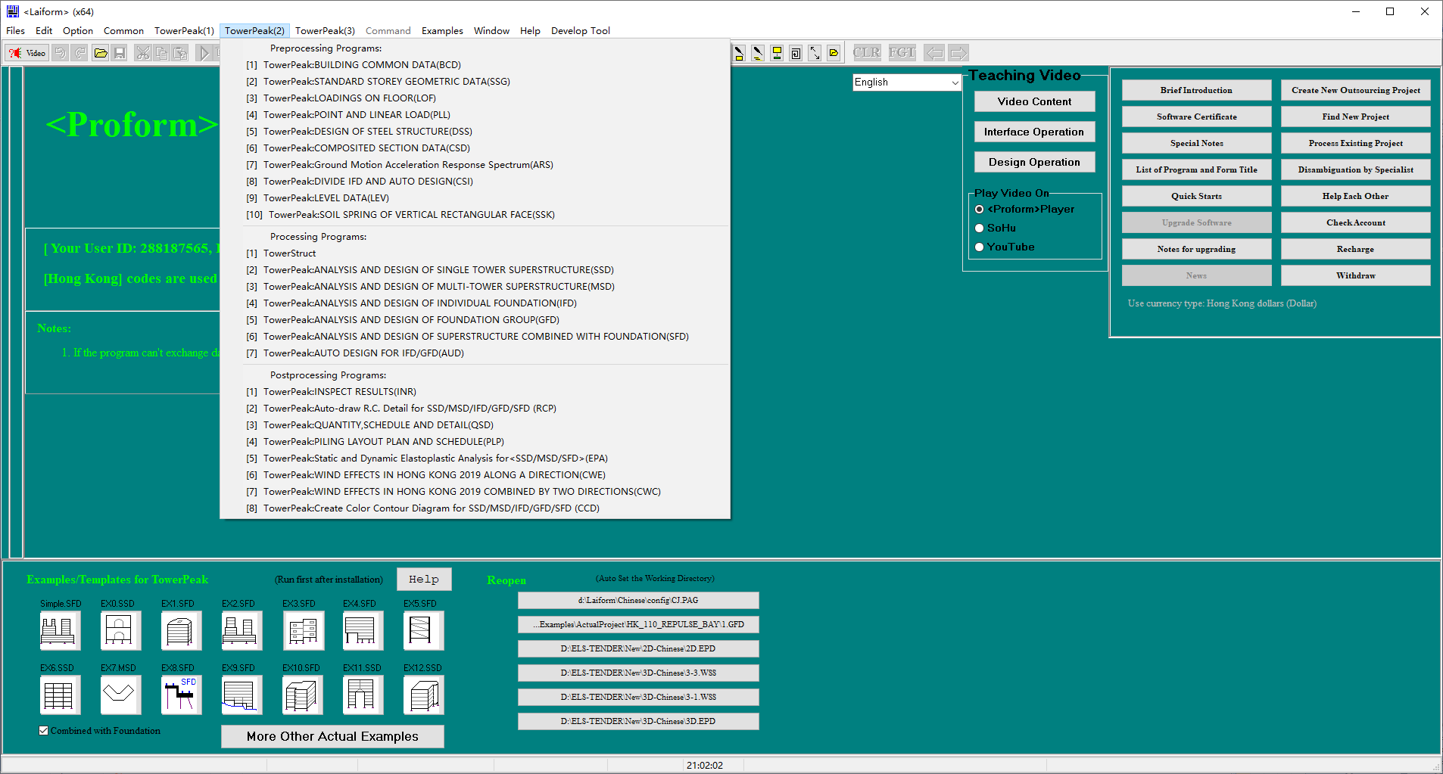

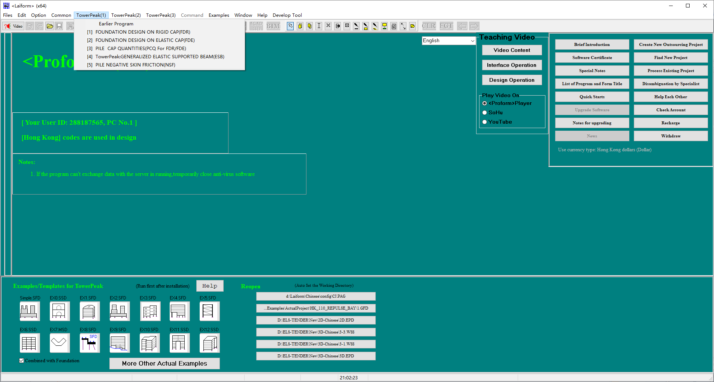

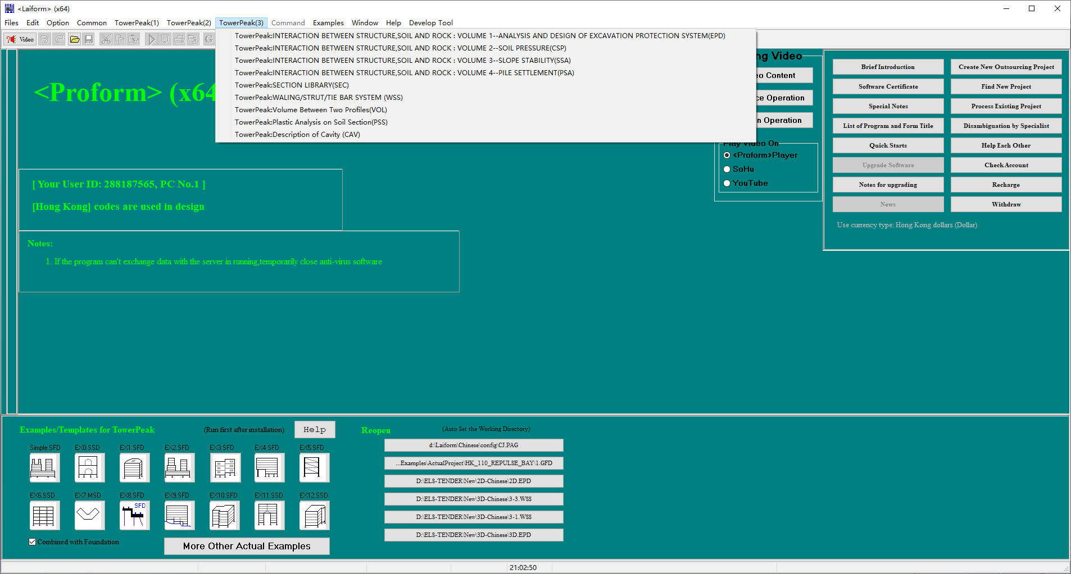

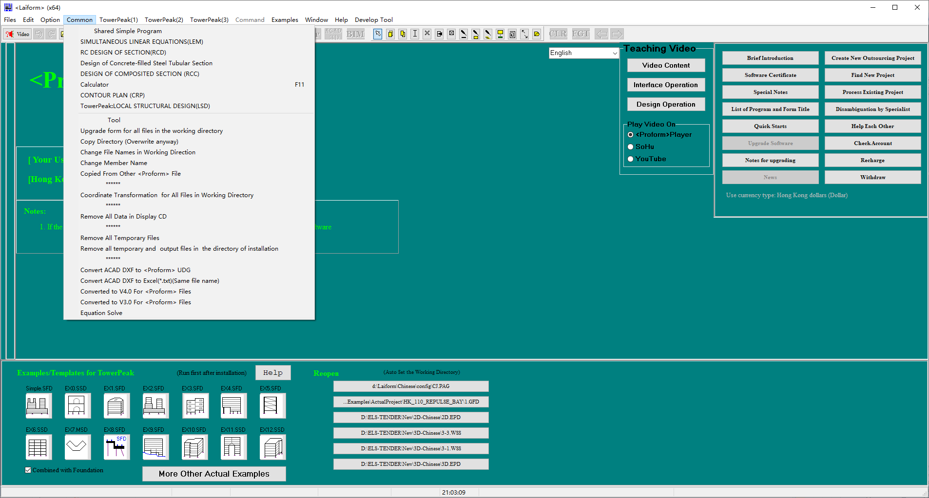

Some real-time automatic processing commands are as follows:

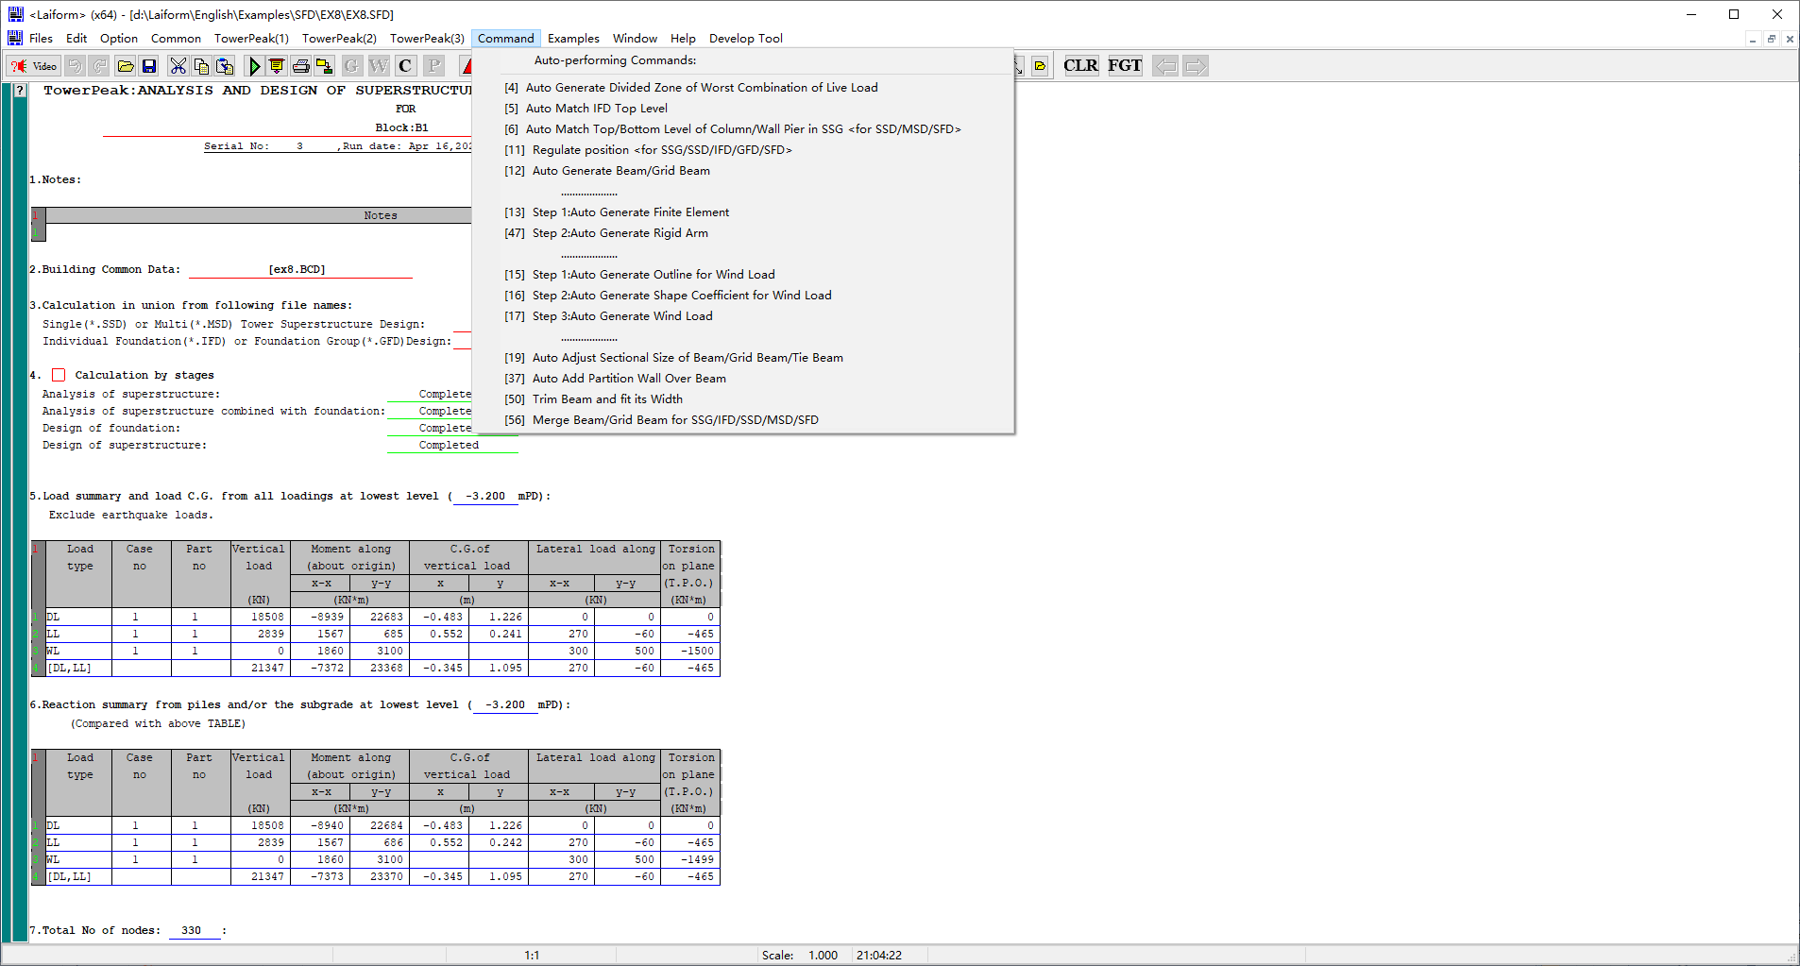

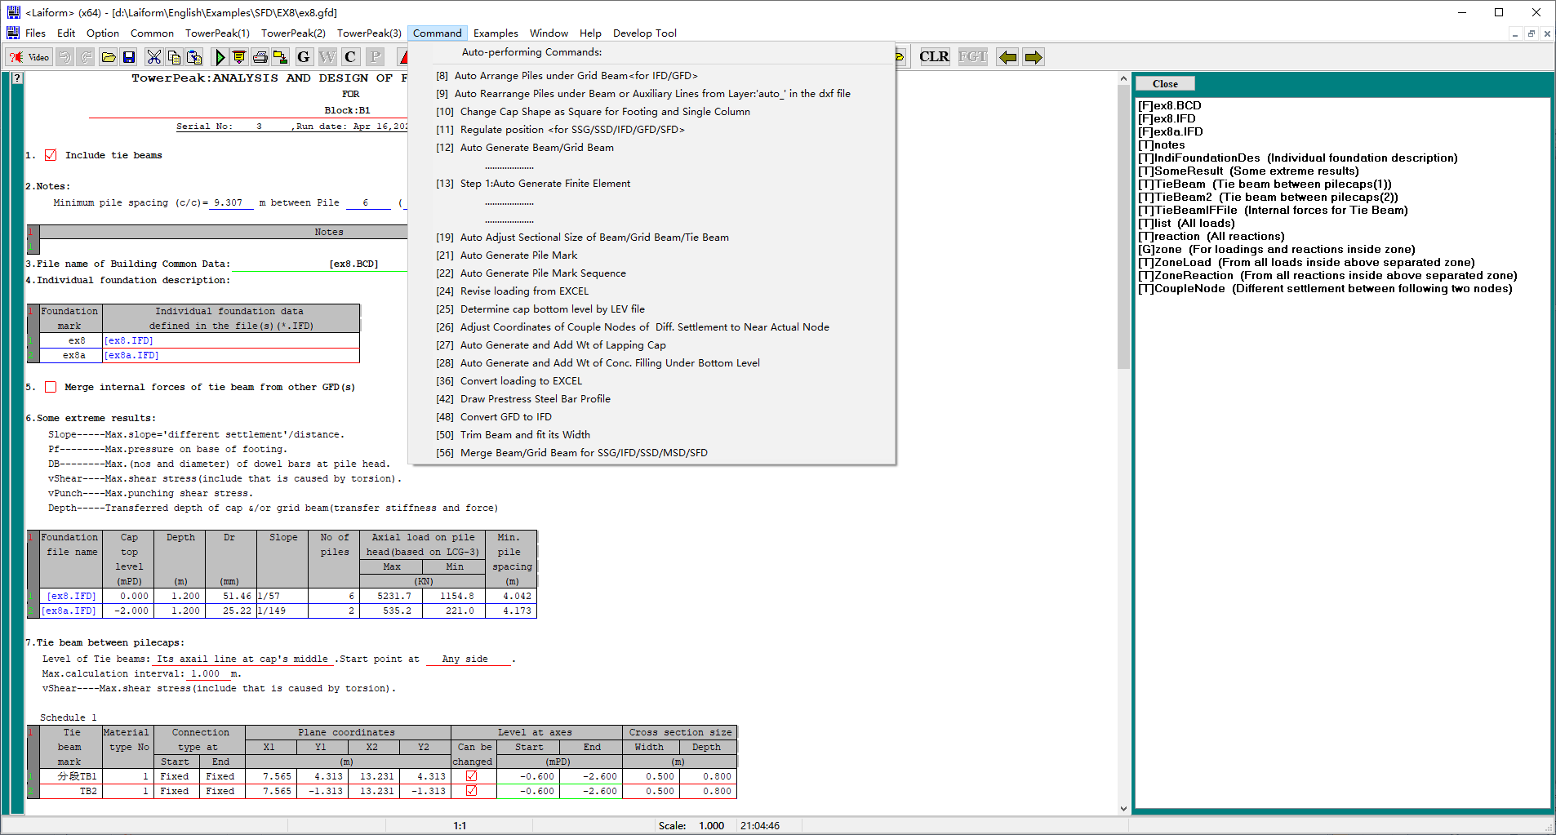

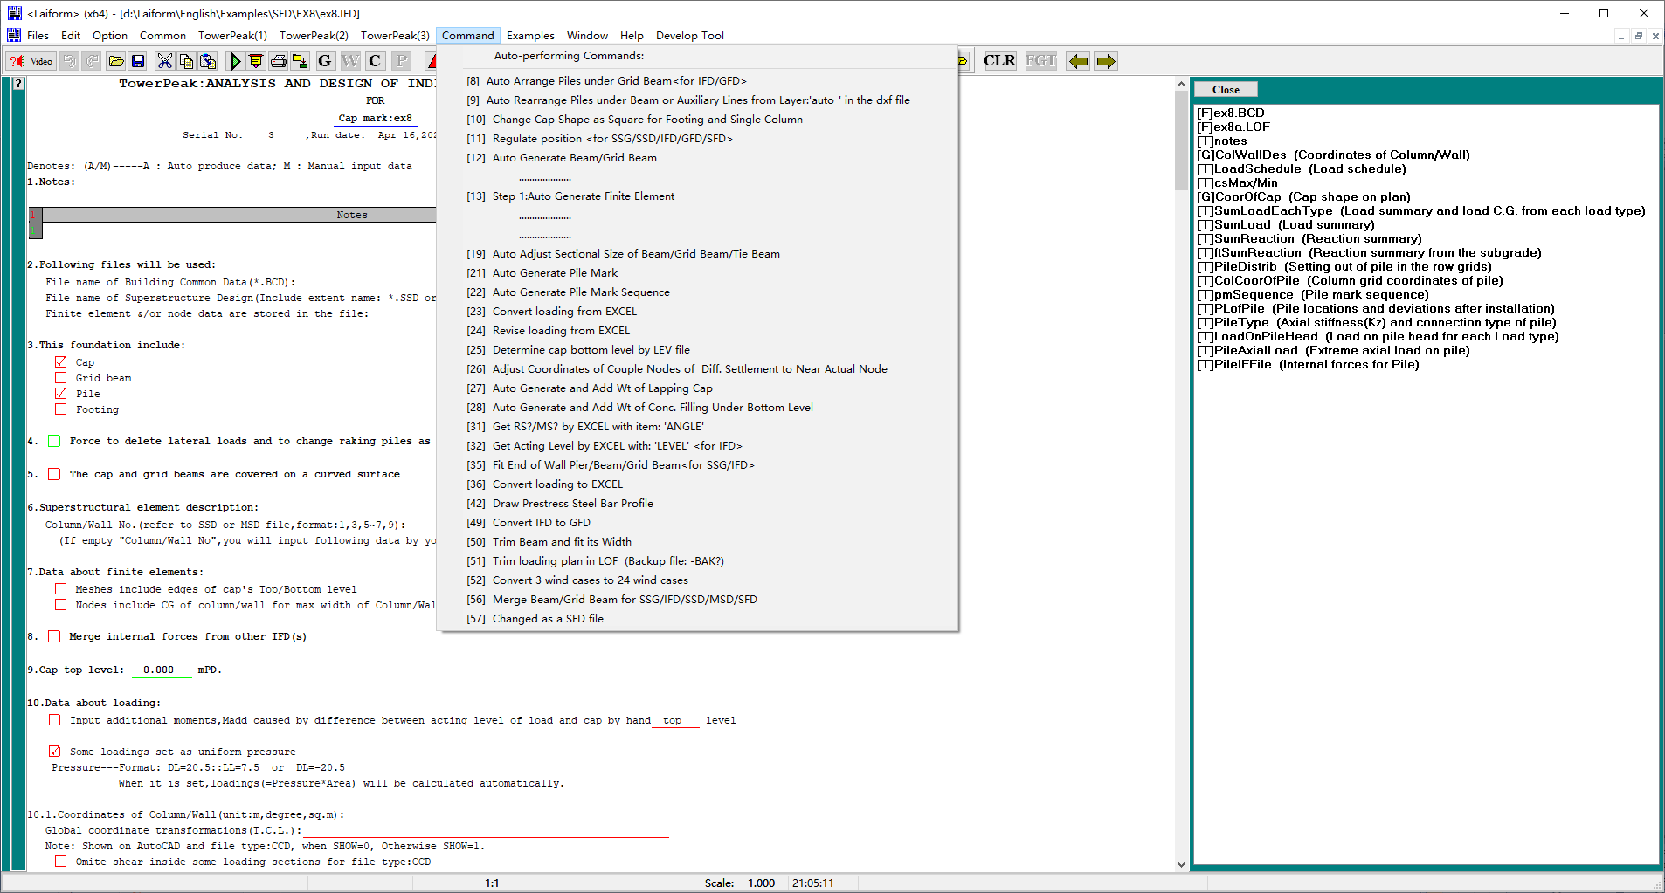

The collected examples are as follows:

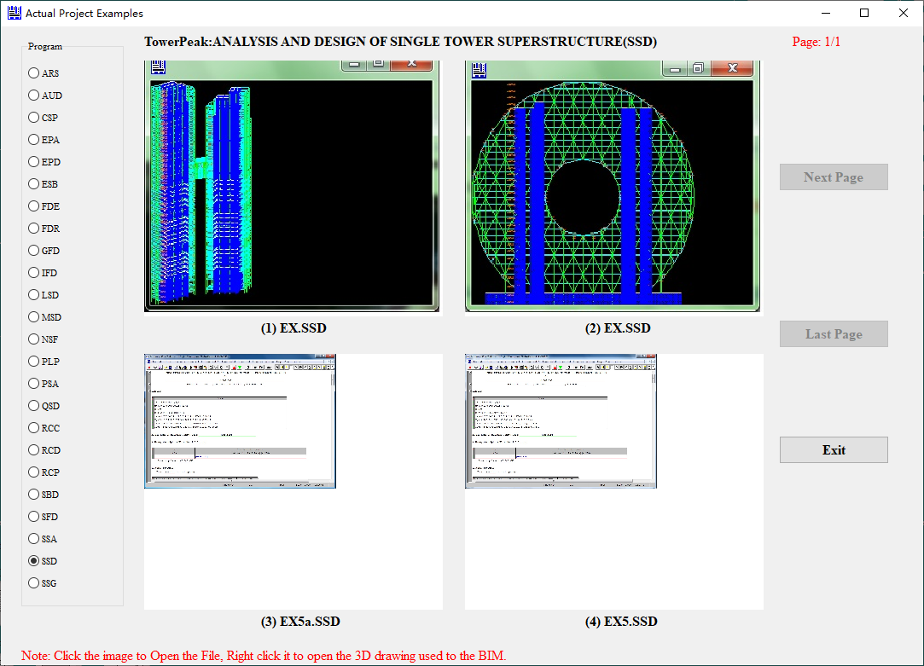

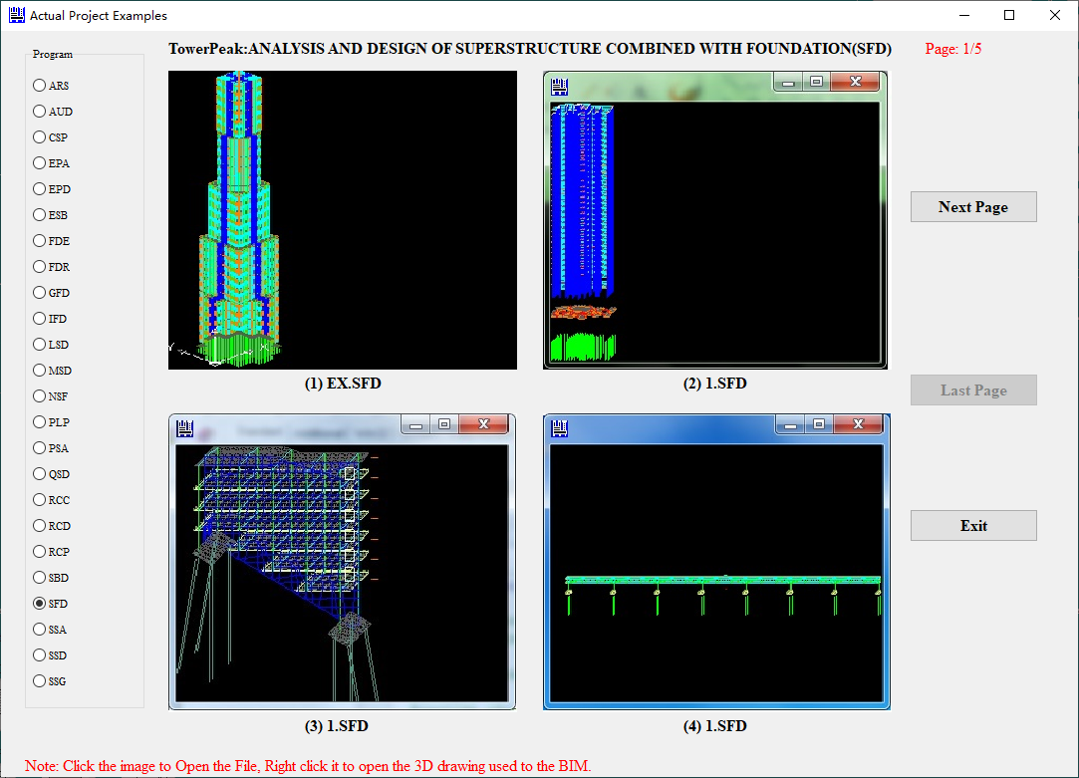

The first image above is a simulated super high-rise building with a height of 1000m and 300 floors

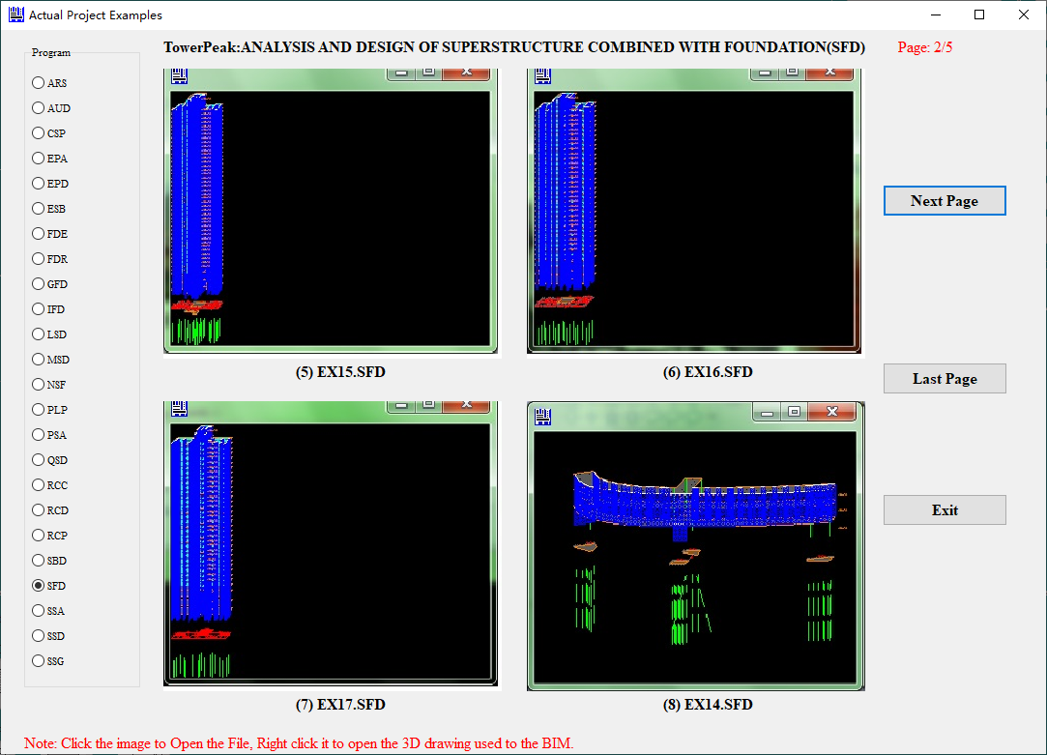

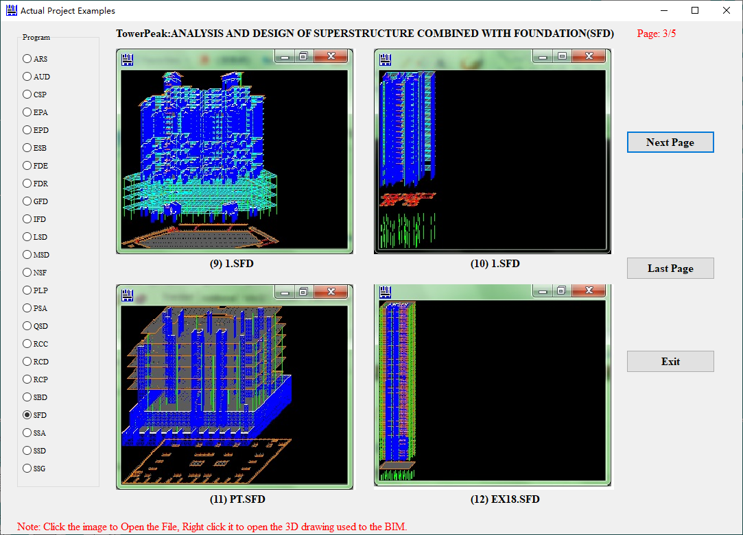

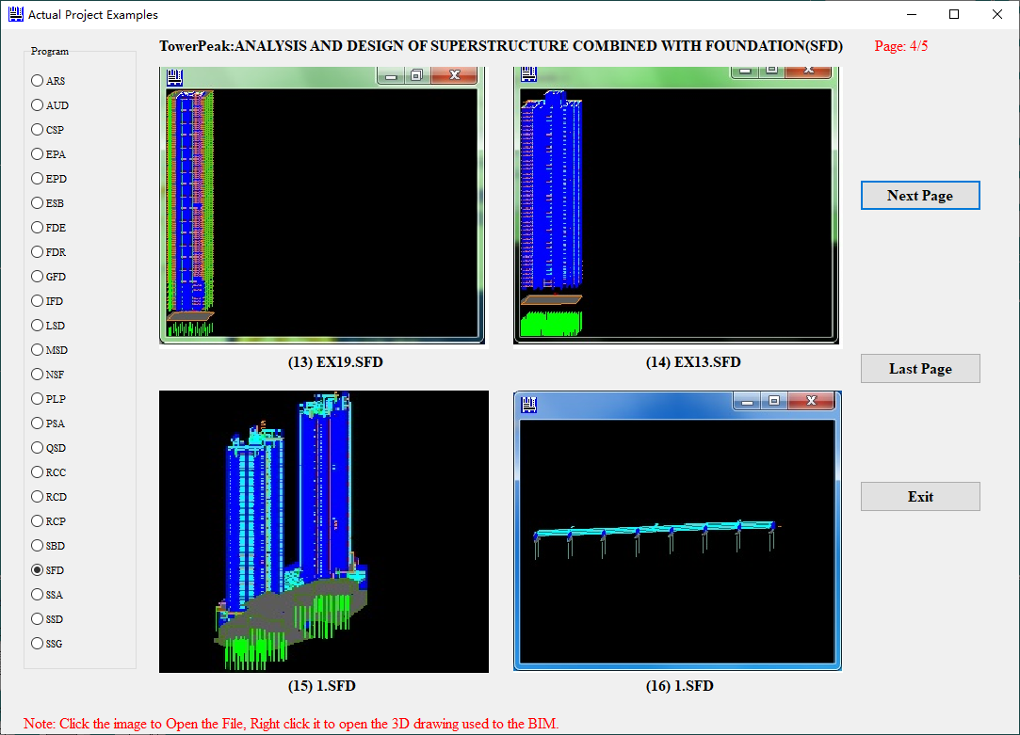

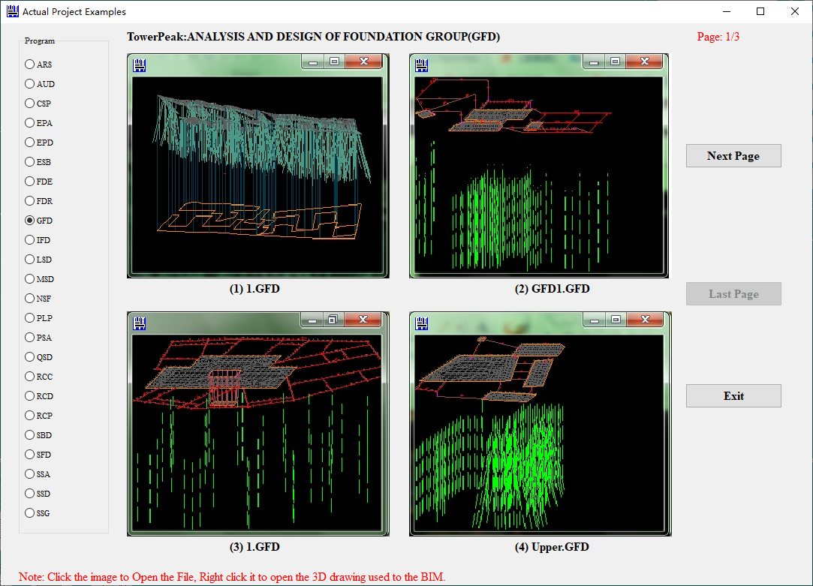

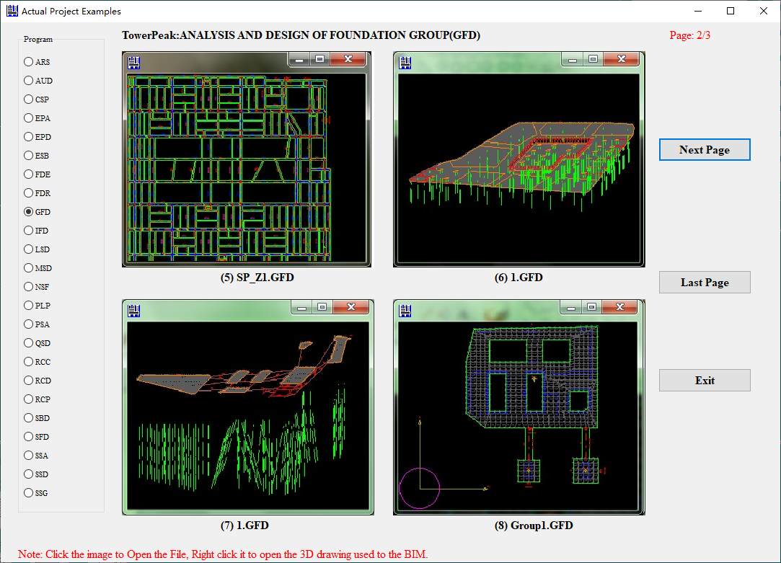

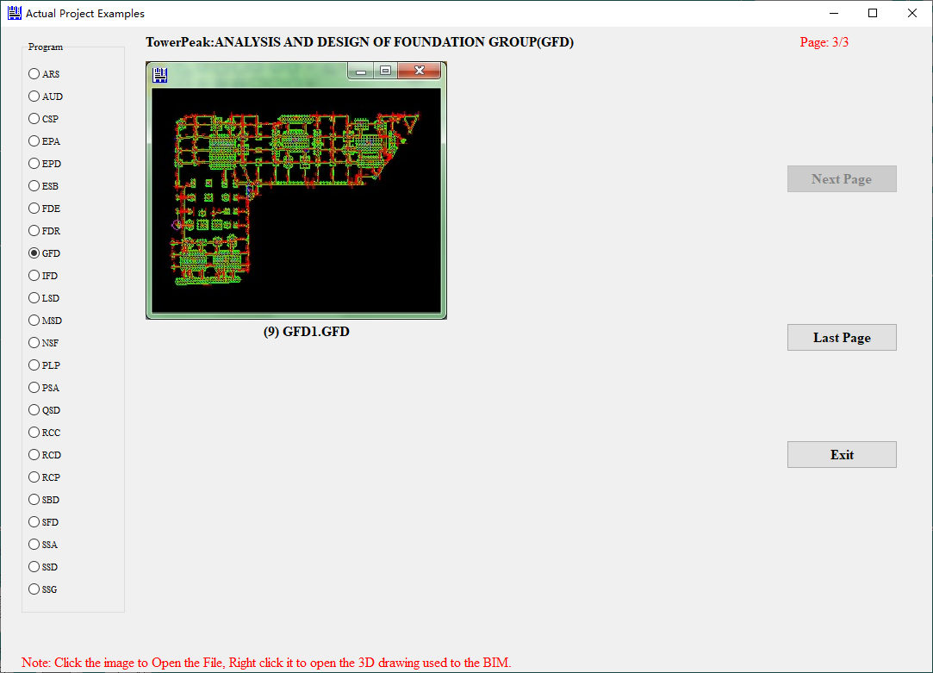

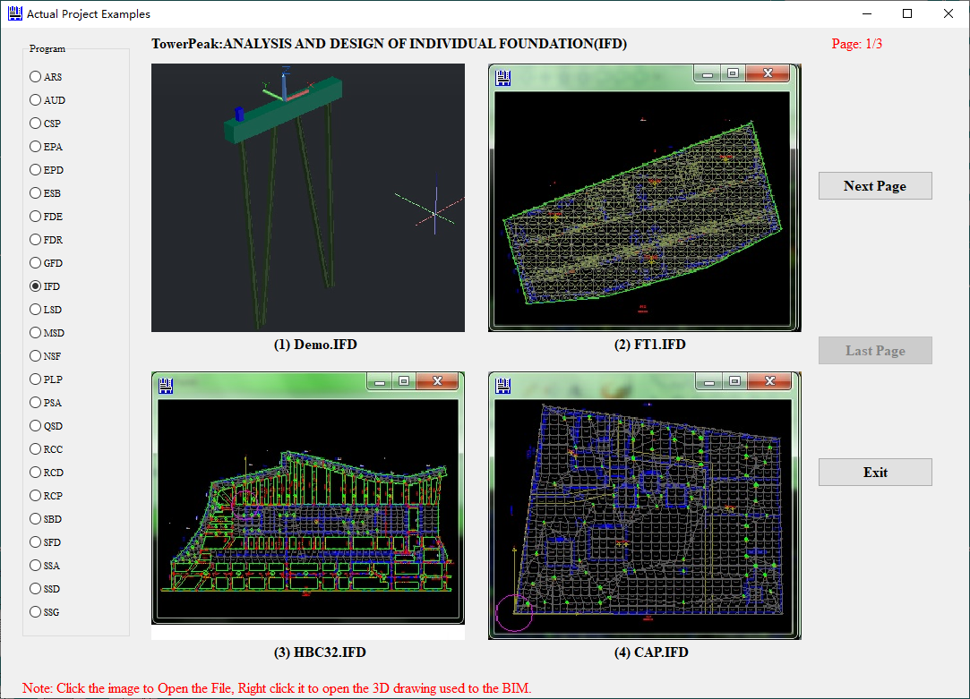

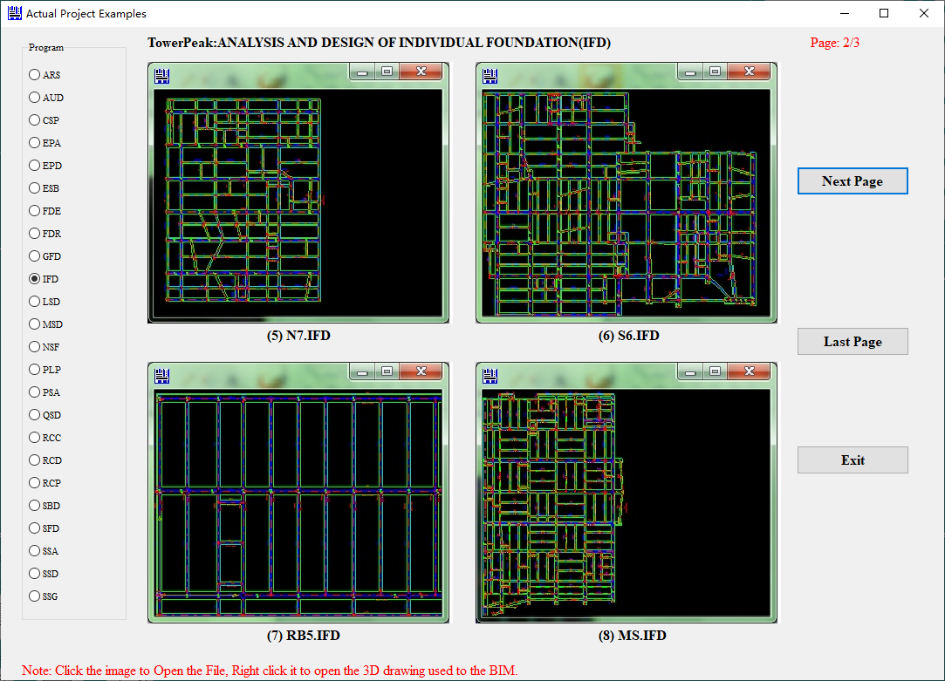

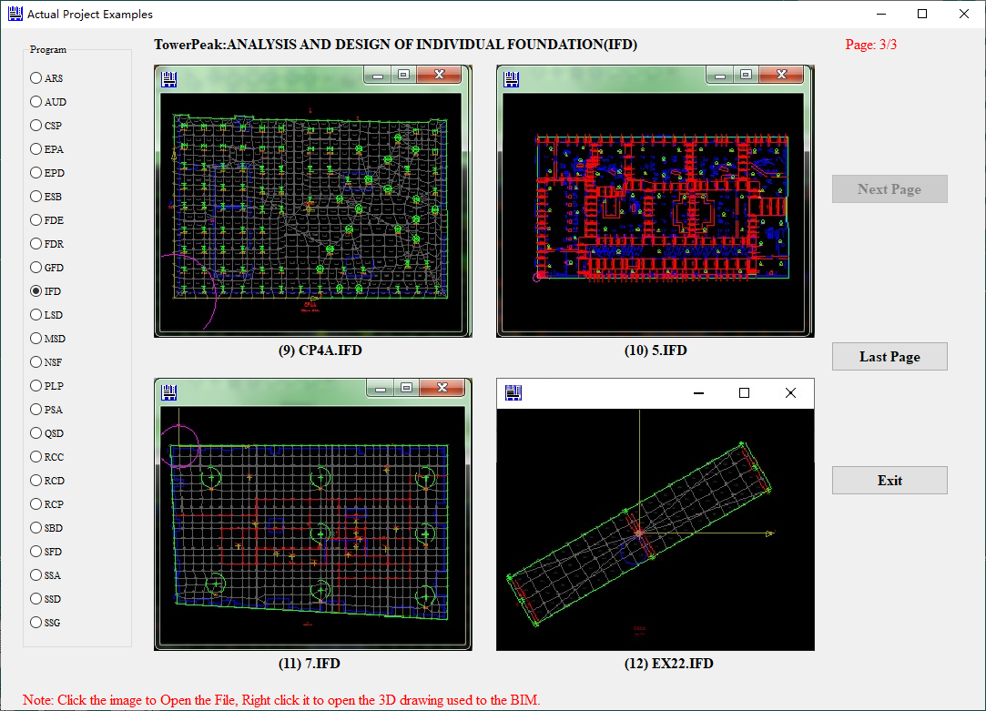

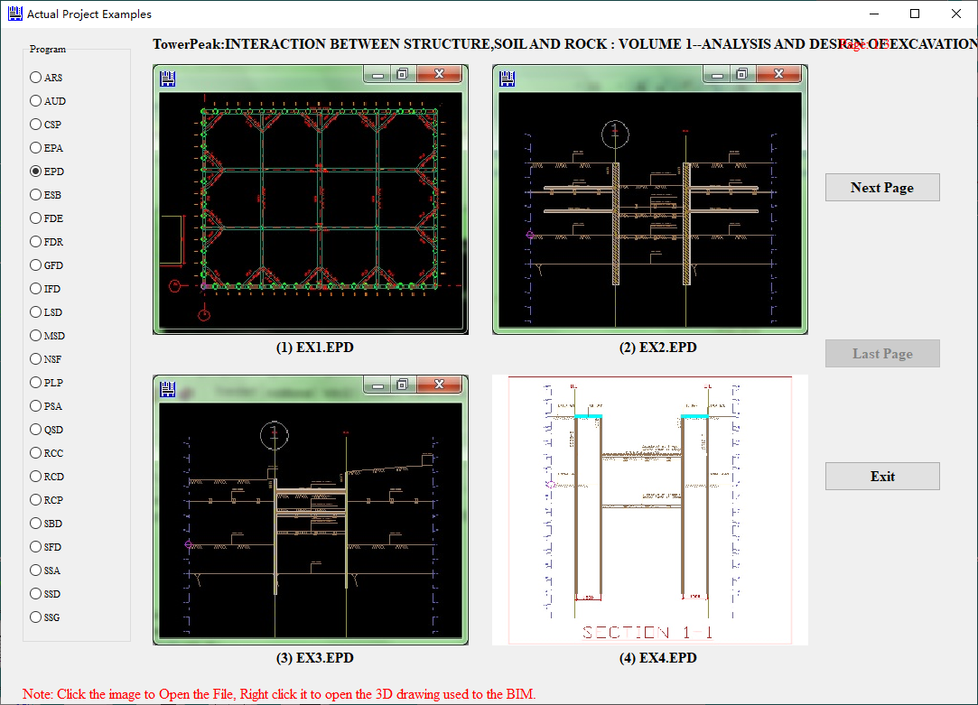

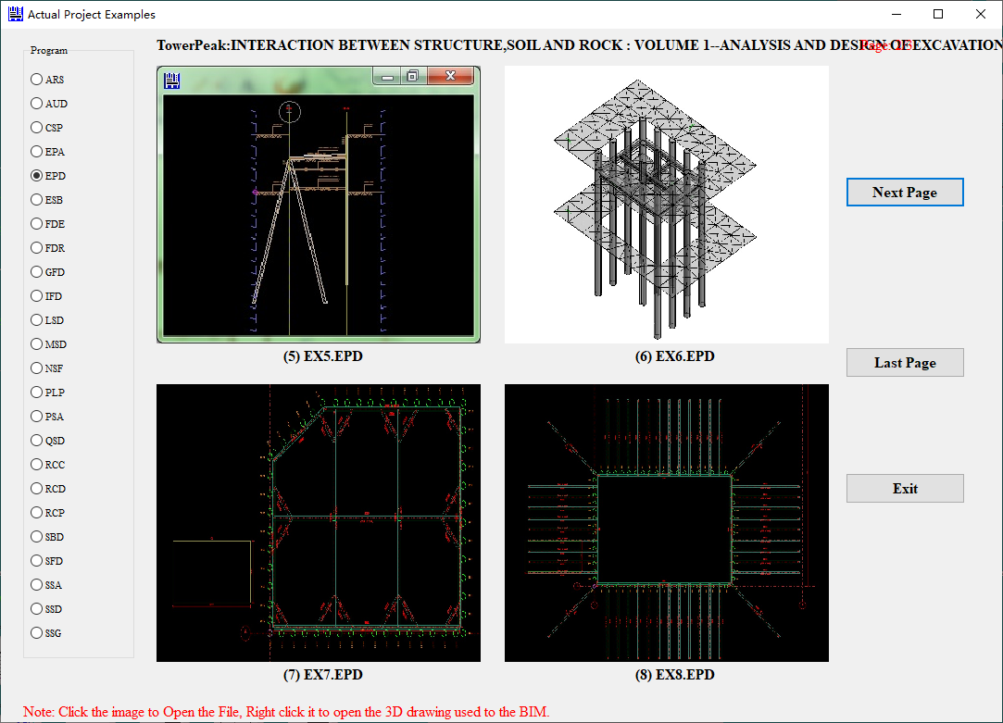

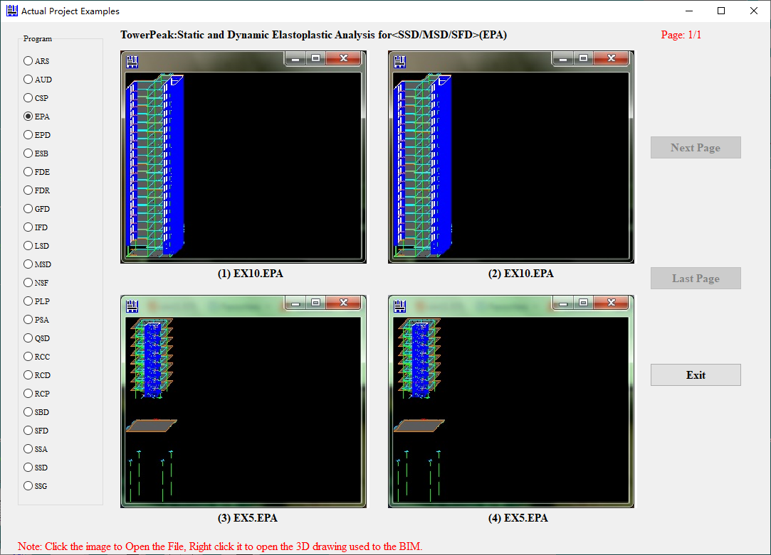

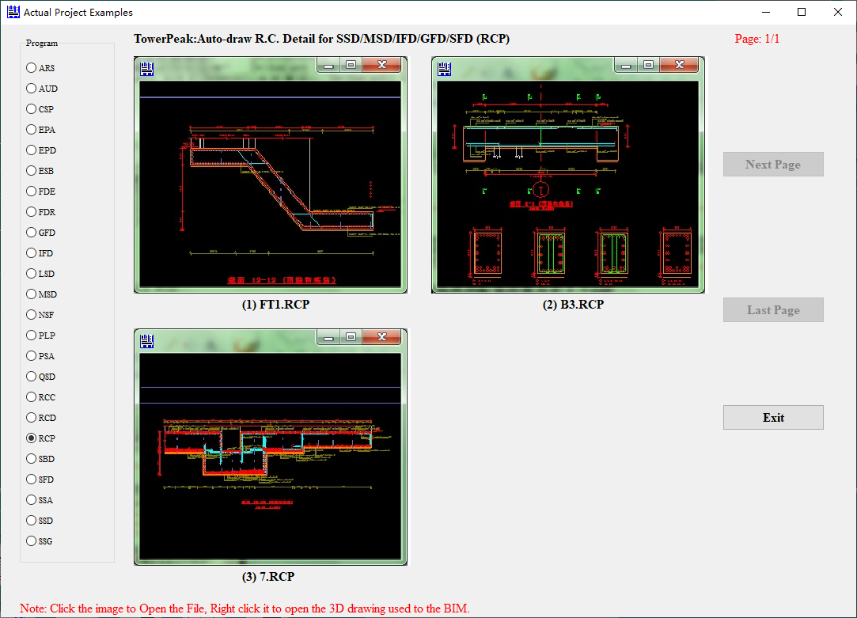

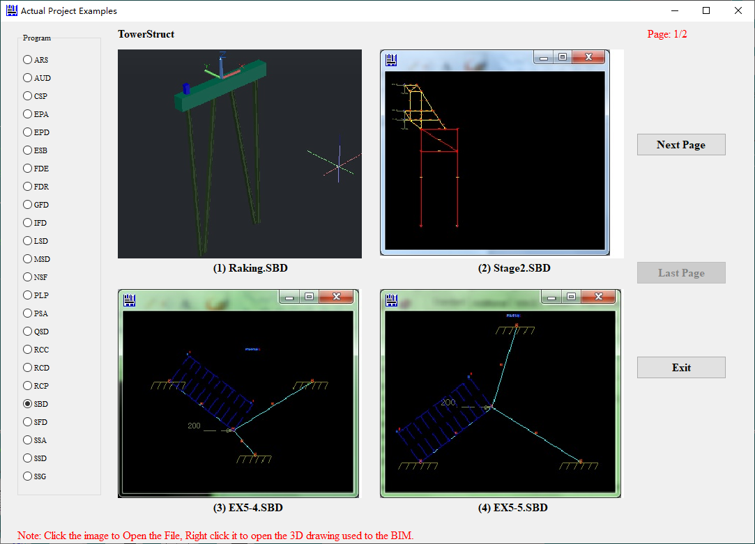

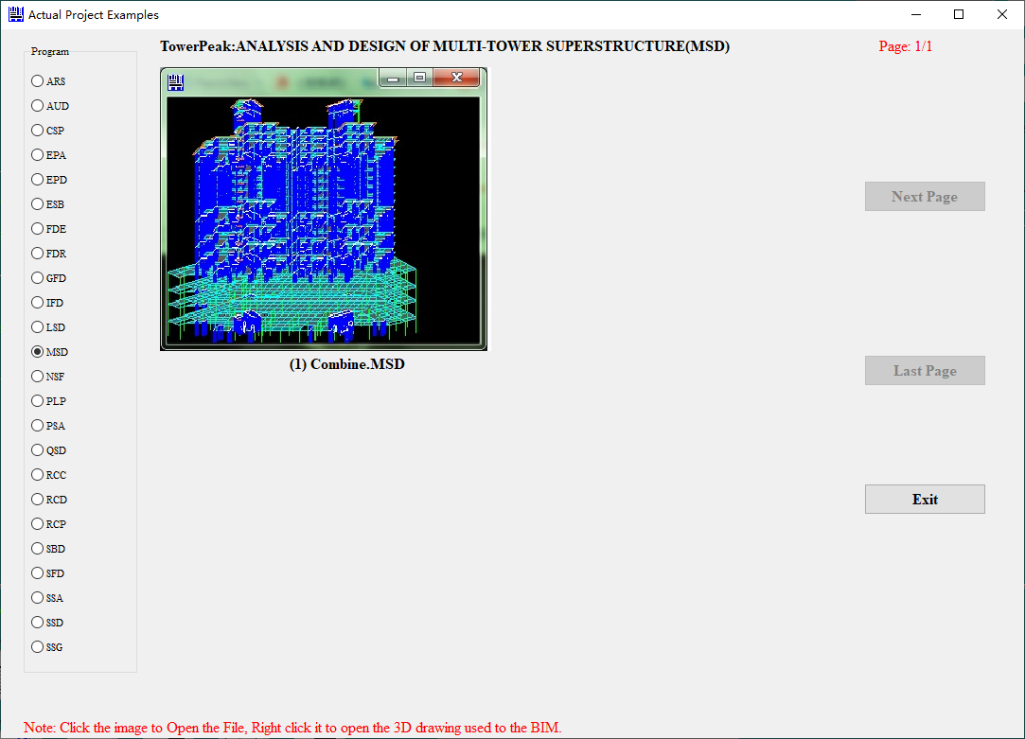

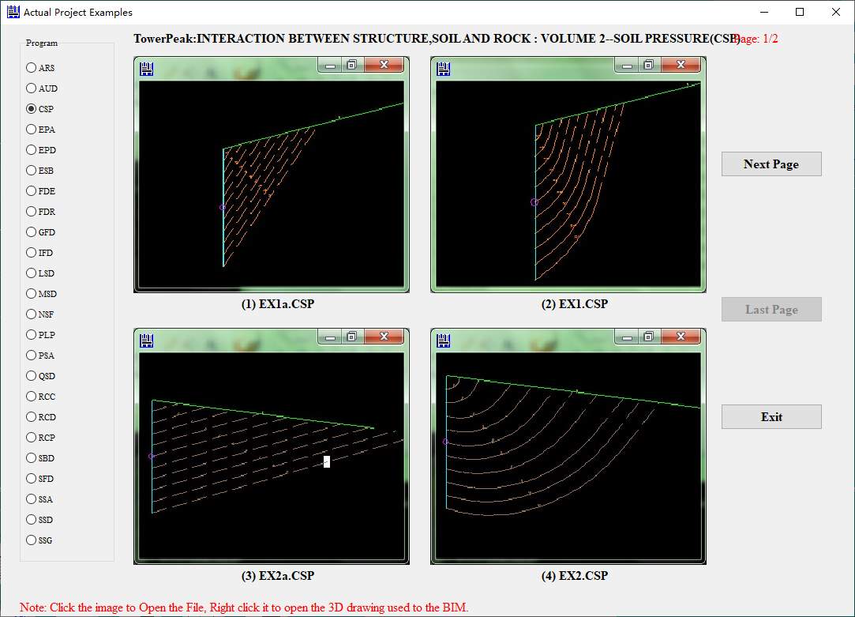

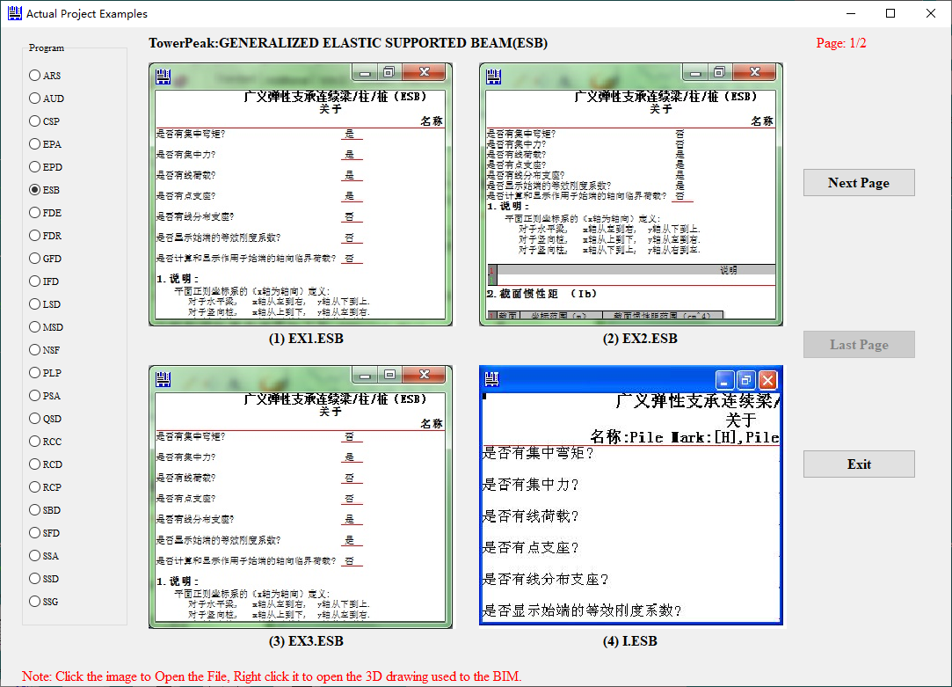

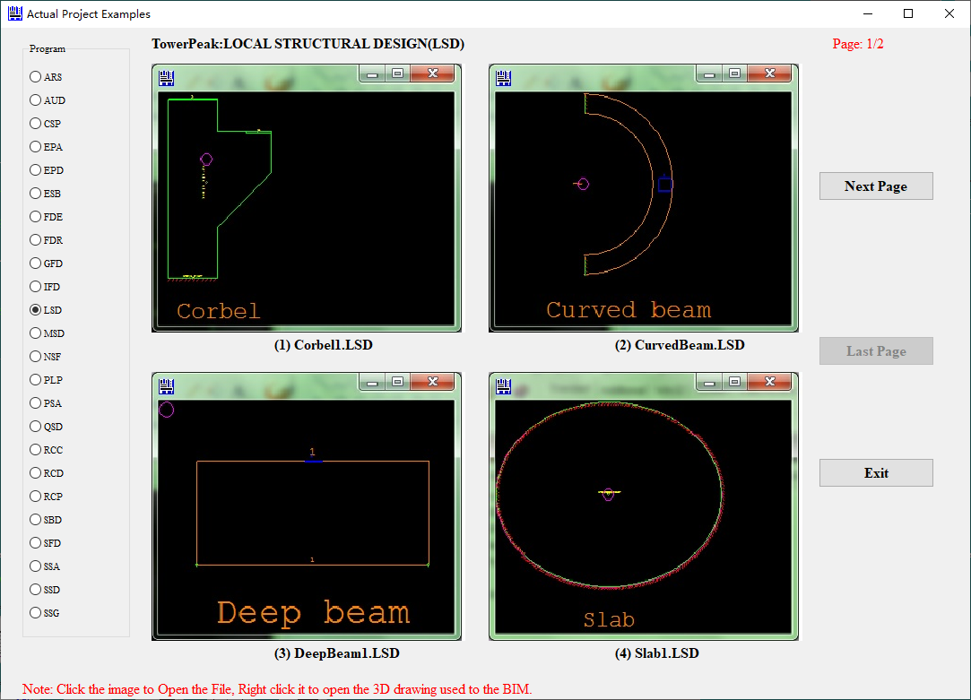

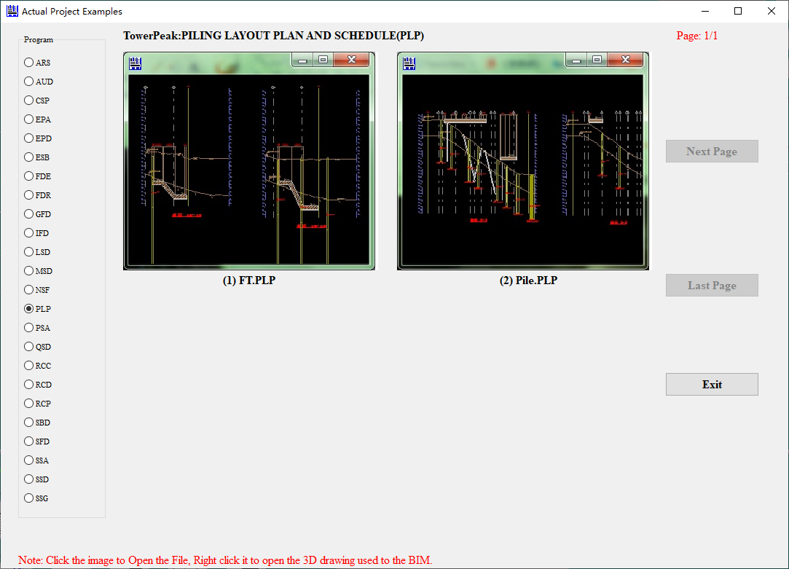

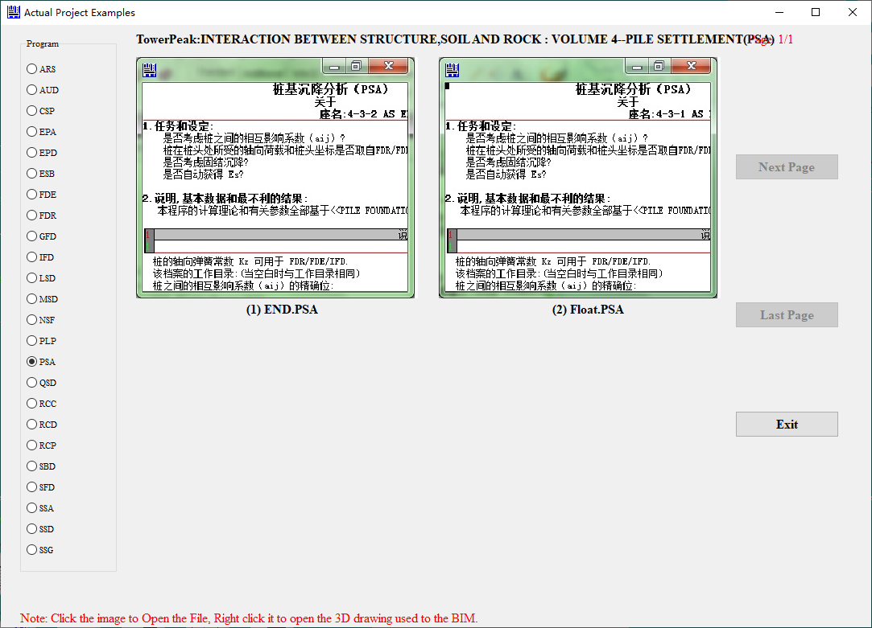

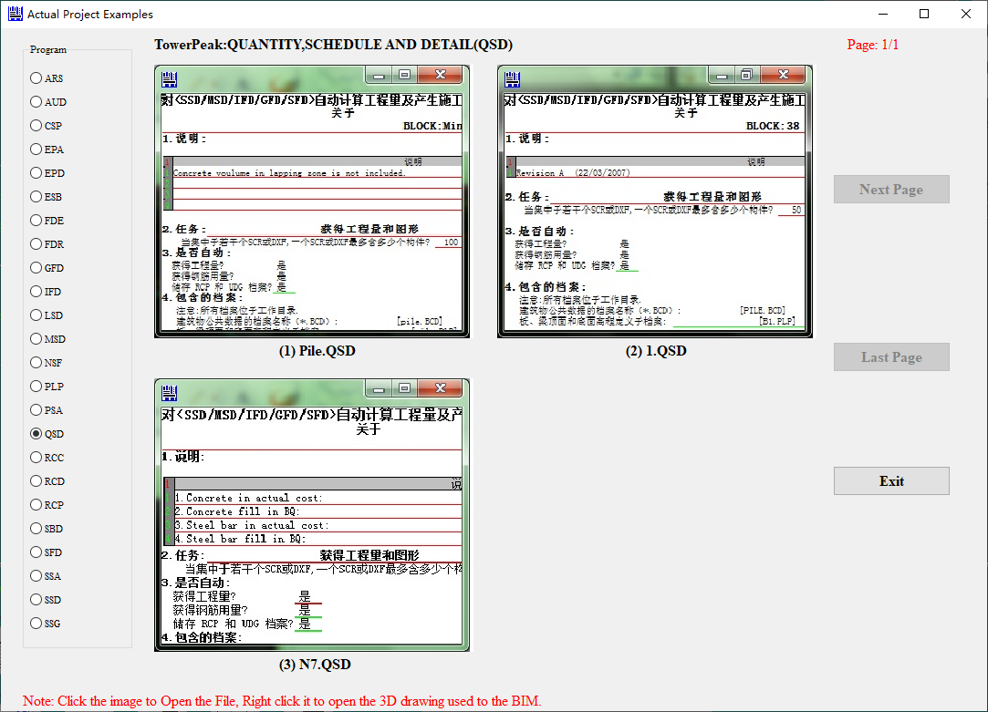

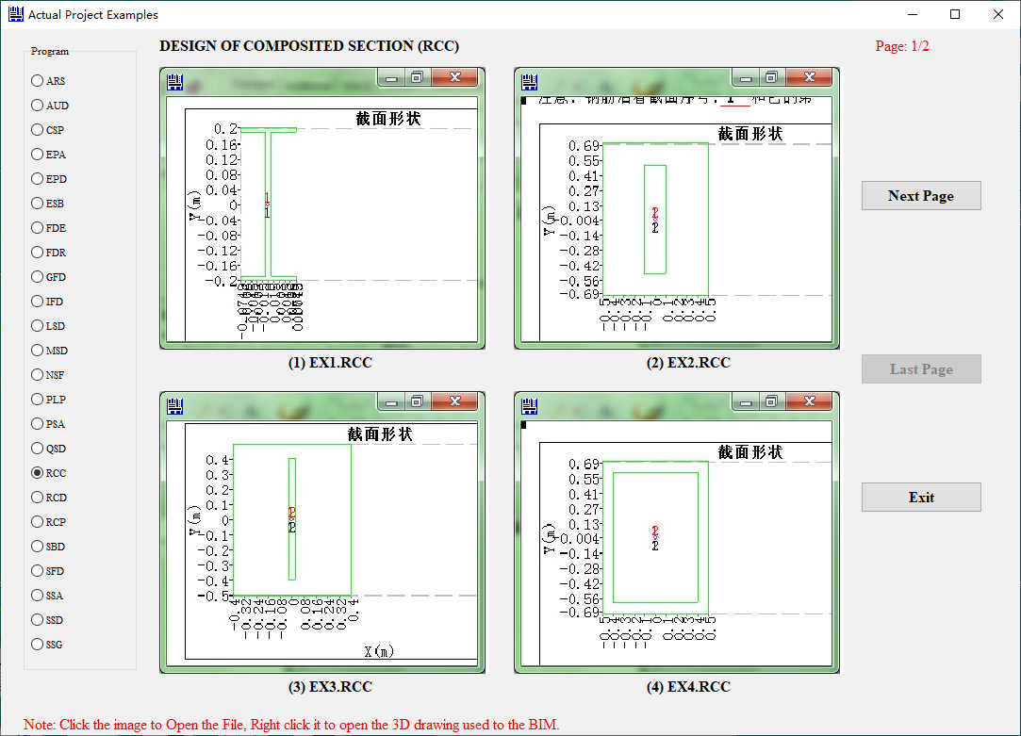

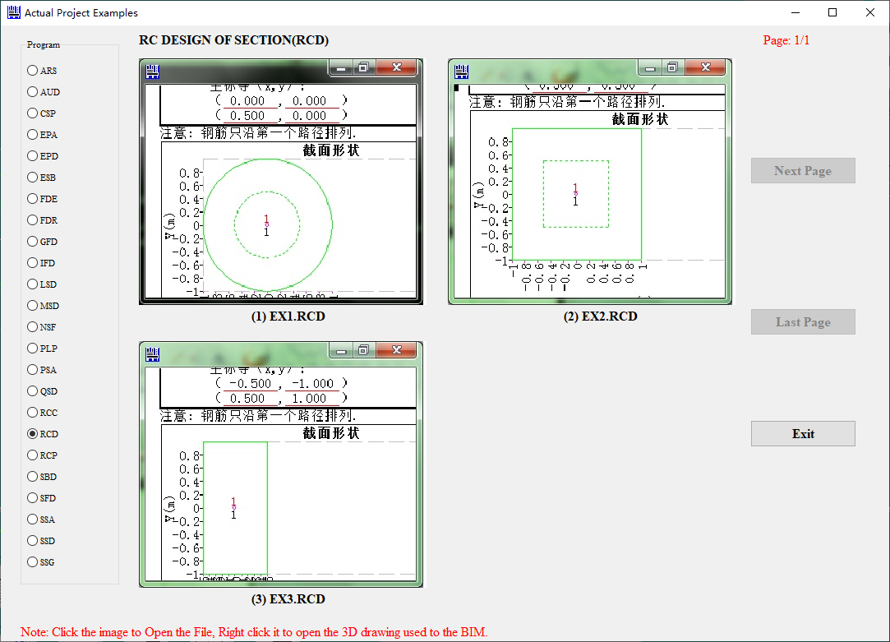

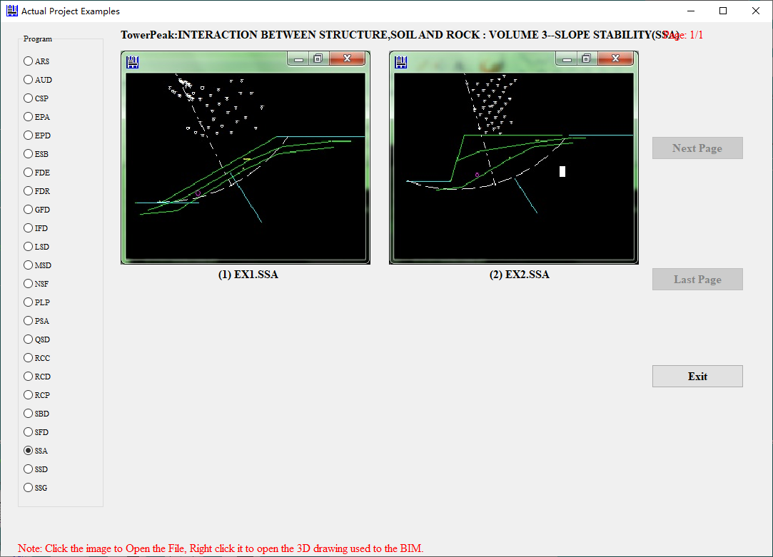

Use the following simple model to illustrate the main functions of this program:

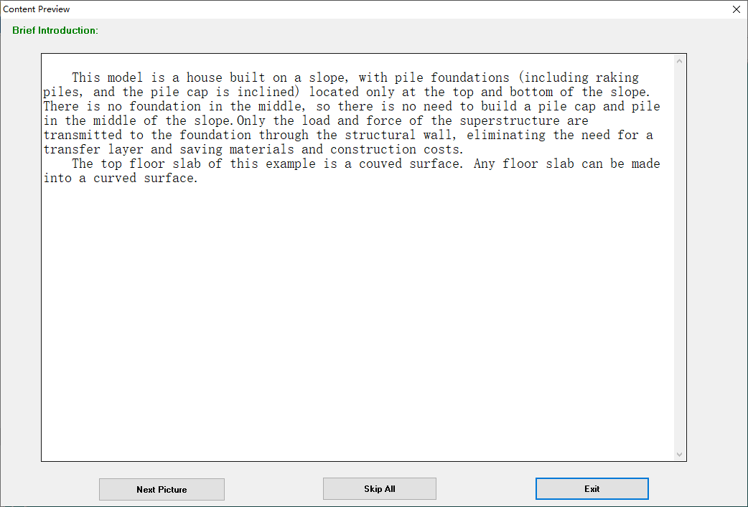

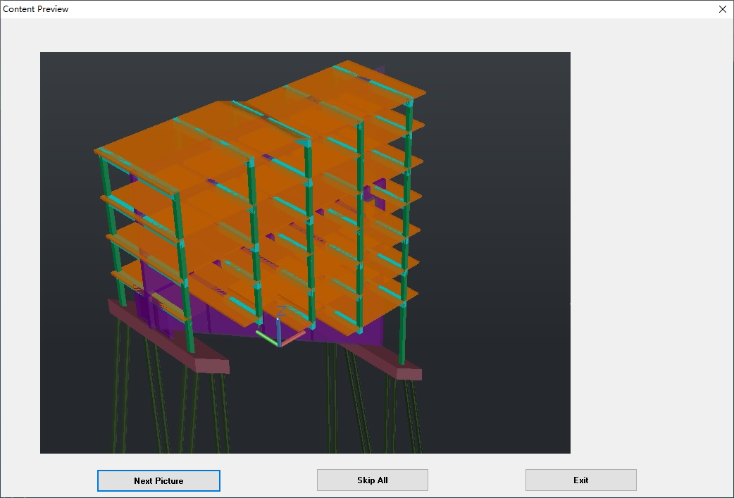

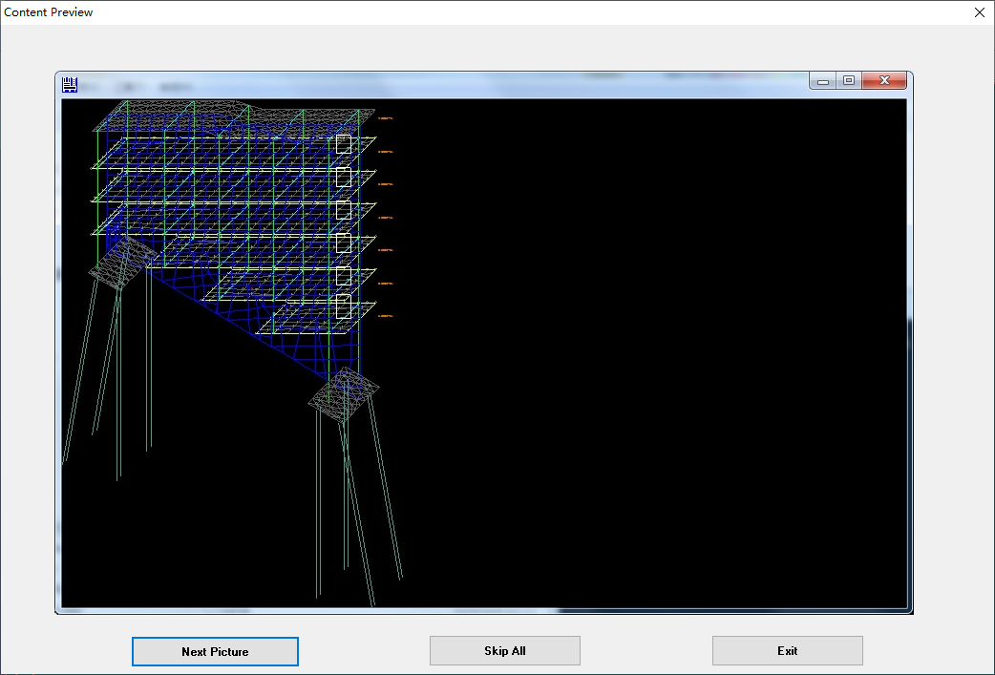

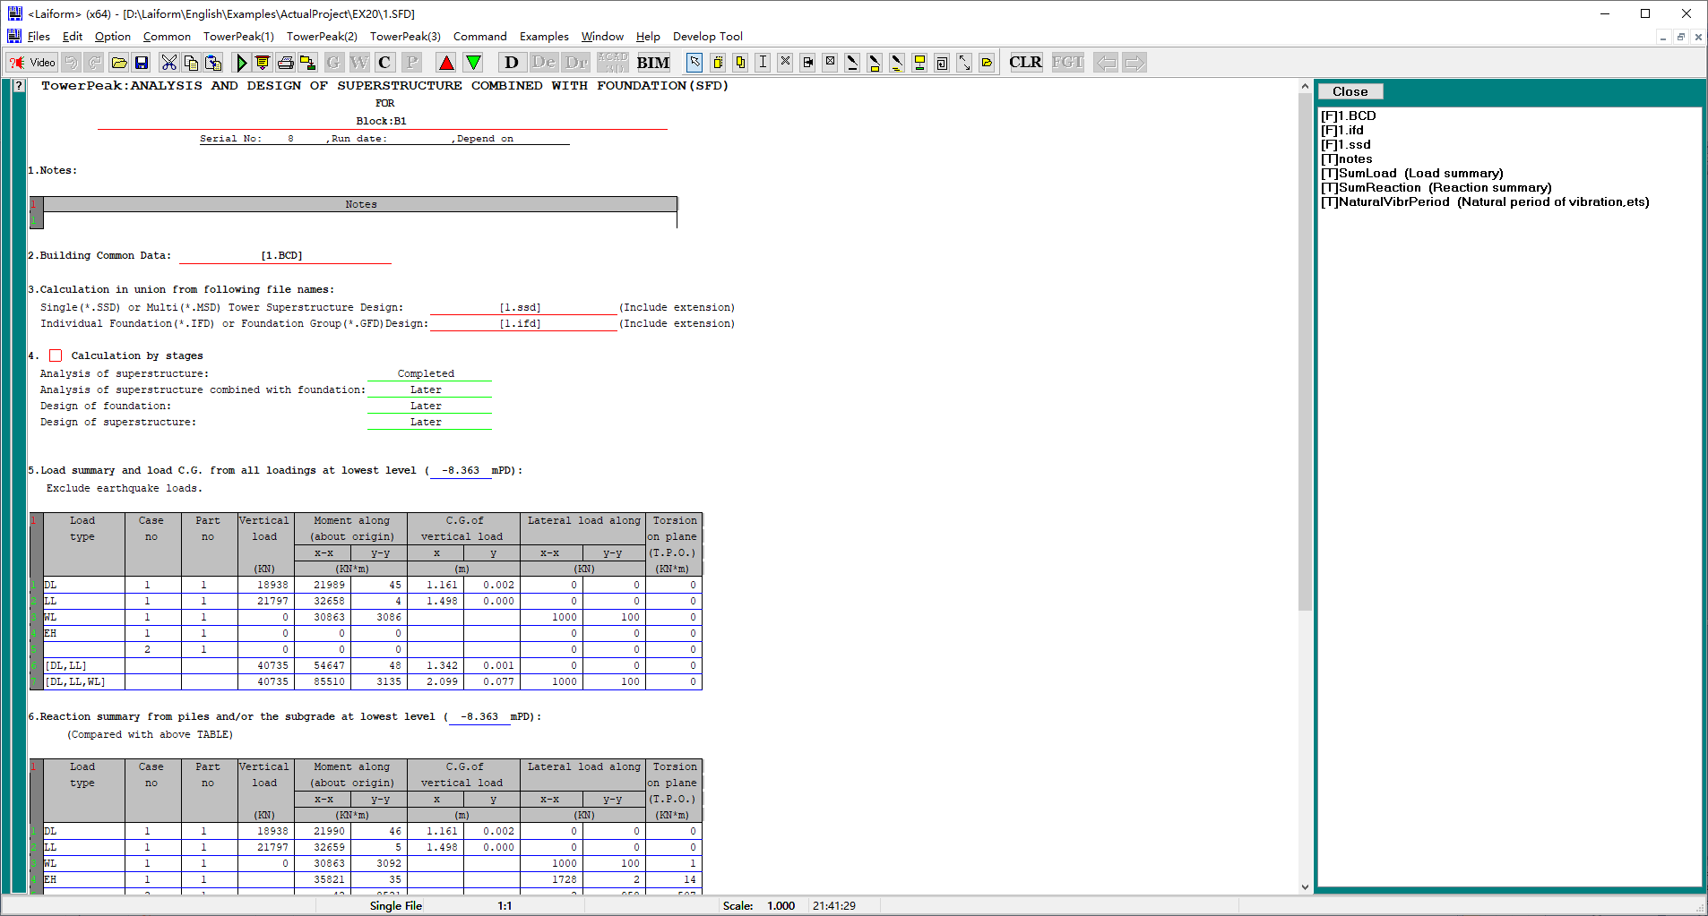

1. Press the BIM button in the above figure to draw a 3D drawing on Revit as shown below

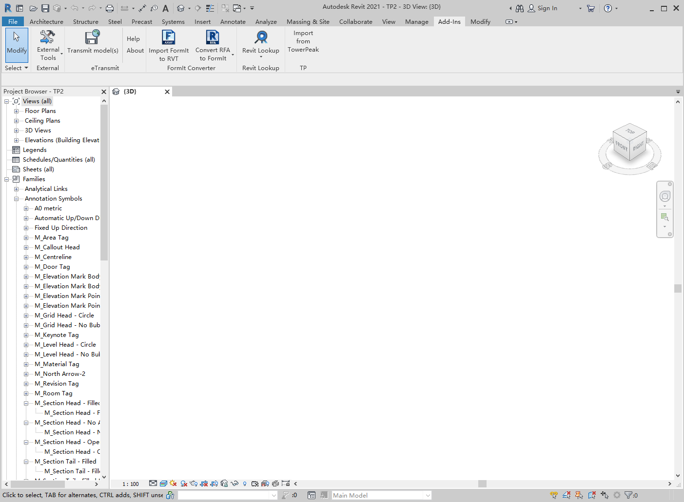

Press “Import from TowerPeak” button on Revit as shoen below,

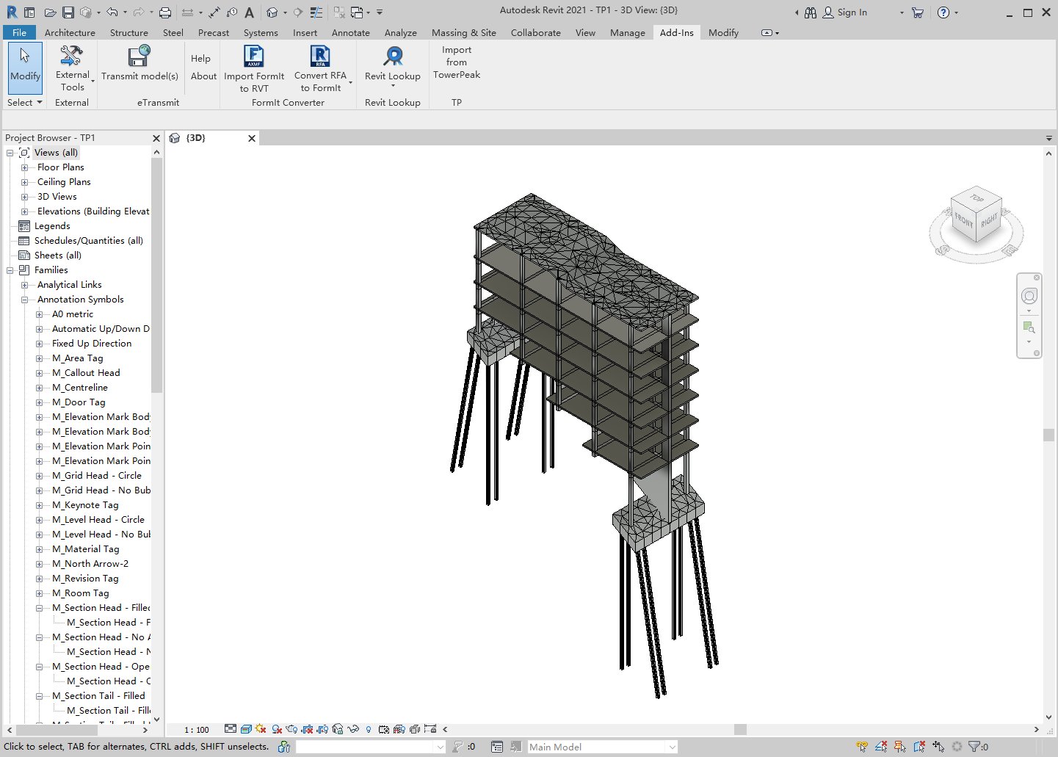

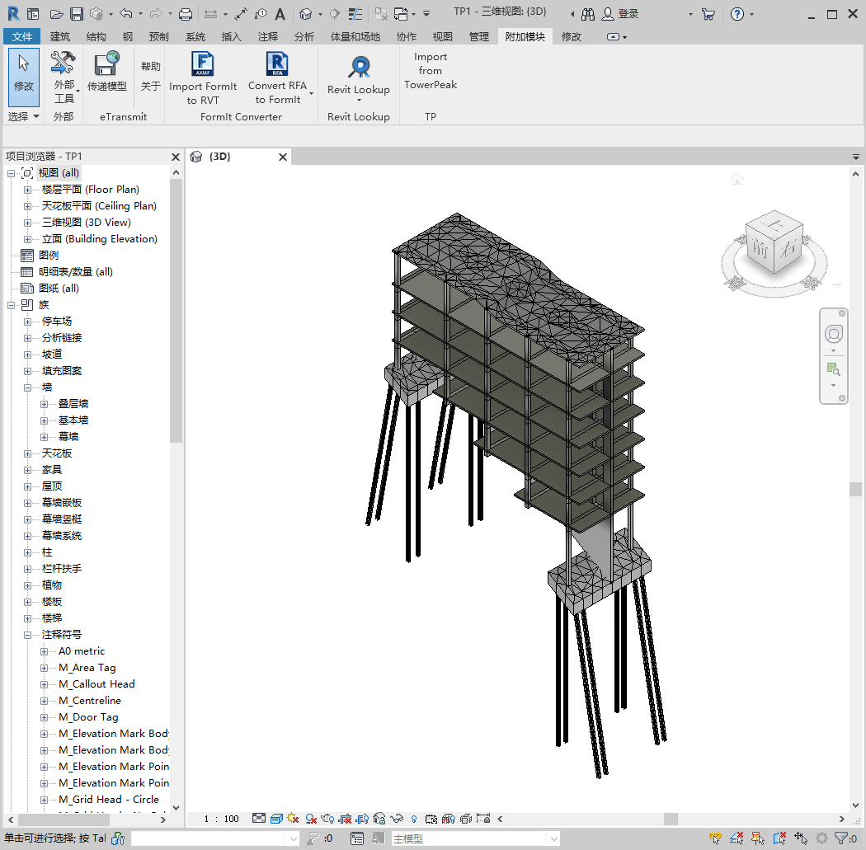

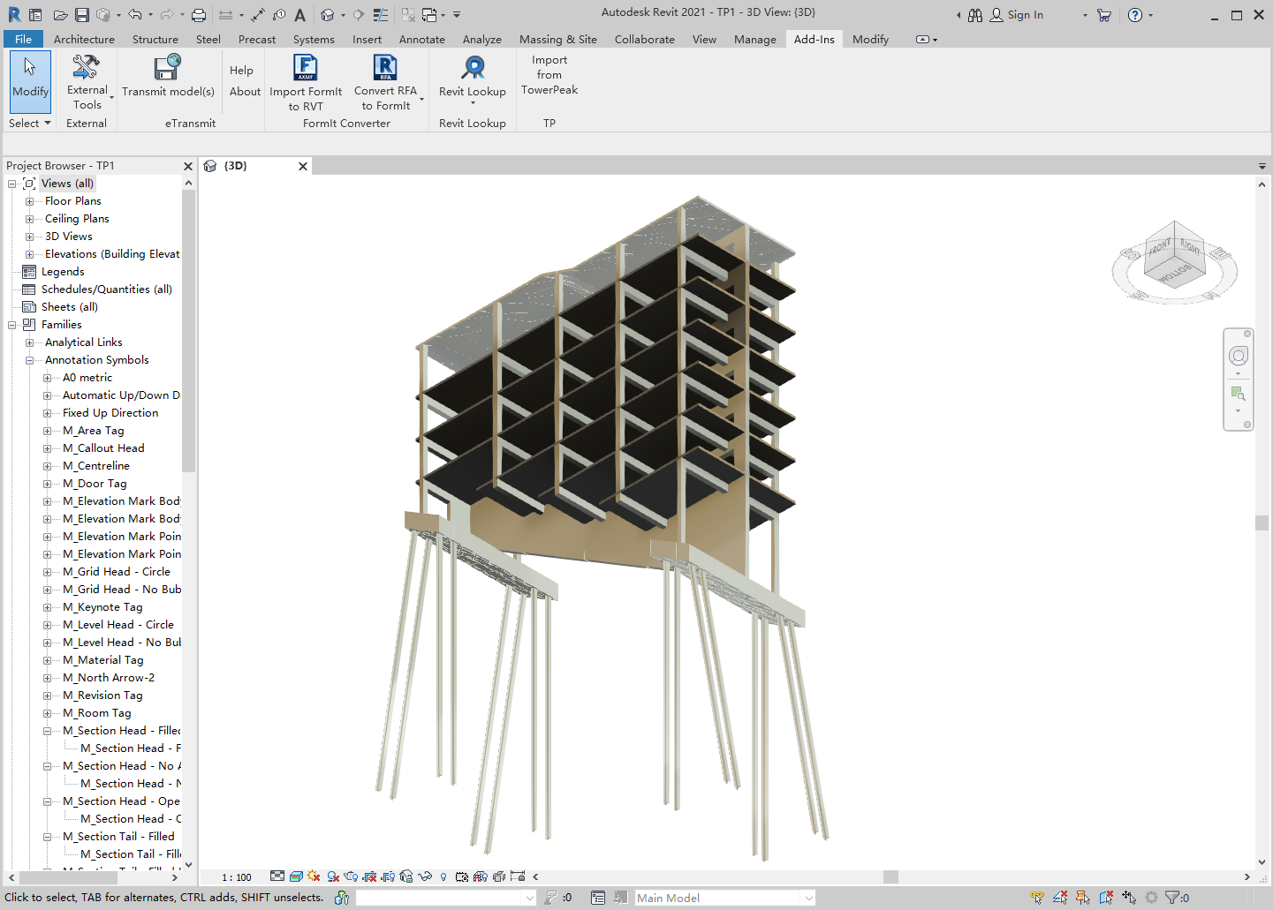

Its main functions are as follows:

1. The superstructure and foundation are combined for overall analysis.
2. Perform finite element partitioning on all floor slabs and wall piers and incorporate them into the overall analysis.
3. The foundation may not be located on the same floor.
4. The floor slab and pile cap can be curved.
5. Any shape of hole can be opened at any position on the floor and wall pier.
6. Raking piles can be used.
7. The elastic constant of the soil spring acting on the pile can be different in four directions. For example, the elastic constant of the soil spring facing the bottom and top of the slope must be different.
8. When conducting elastic-plastic dynamic time history elastoplastic analysis, the of damping balls can be included, which plays a significant role in reducing horizontal defection caused by wind and seismic forces.
9. It has powerful features such as options 4.1 to 4.8 and 5.25 shown in the following figure (which can use prestressed steel bars for prestressed section design of floor slabs, pilecaps and beams to reduce steel bar usage and vertical deformation).

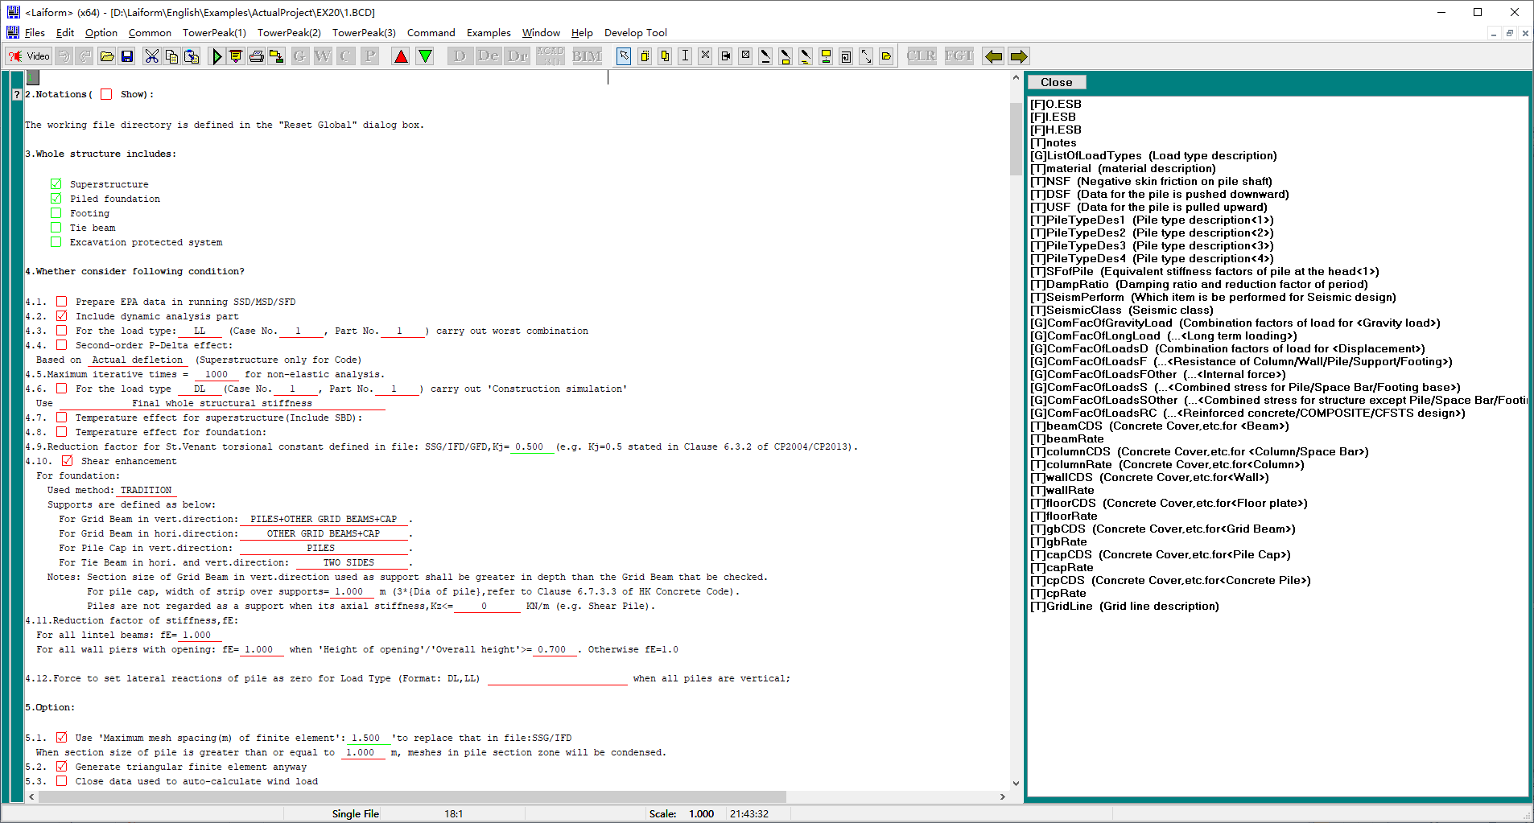

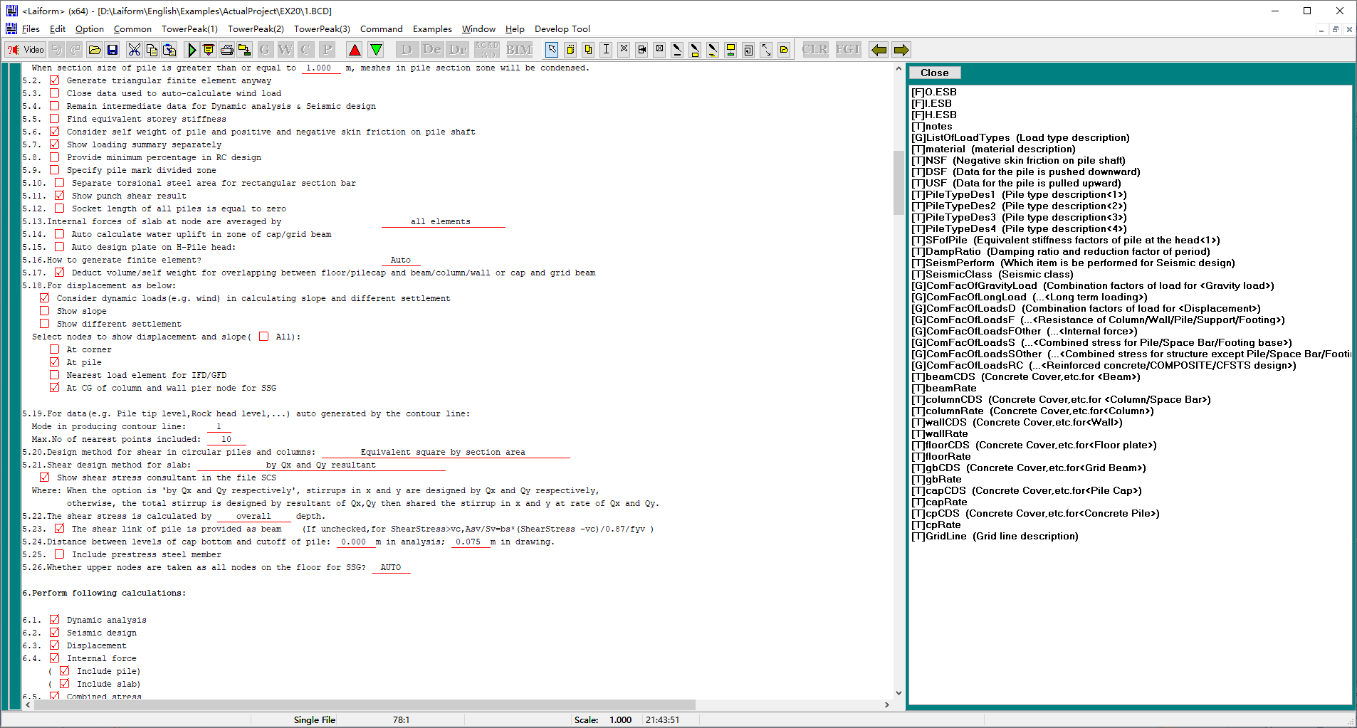

1. 3D outline drawings and 3D reinforcement drawings of components can be automatically created on Revit, and the latter also lists the total amount of steel bars required (including the total length required for each steel bar diameter).

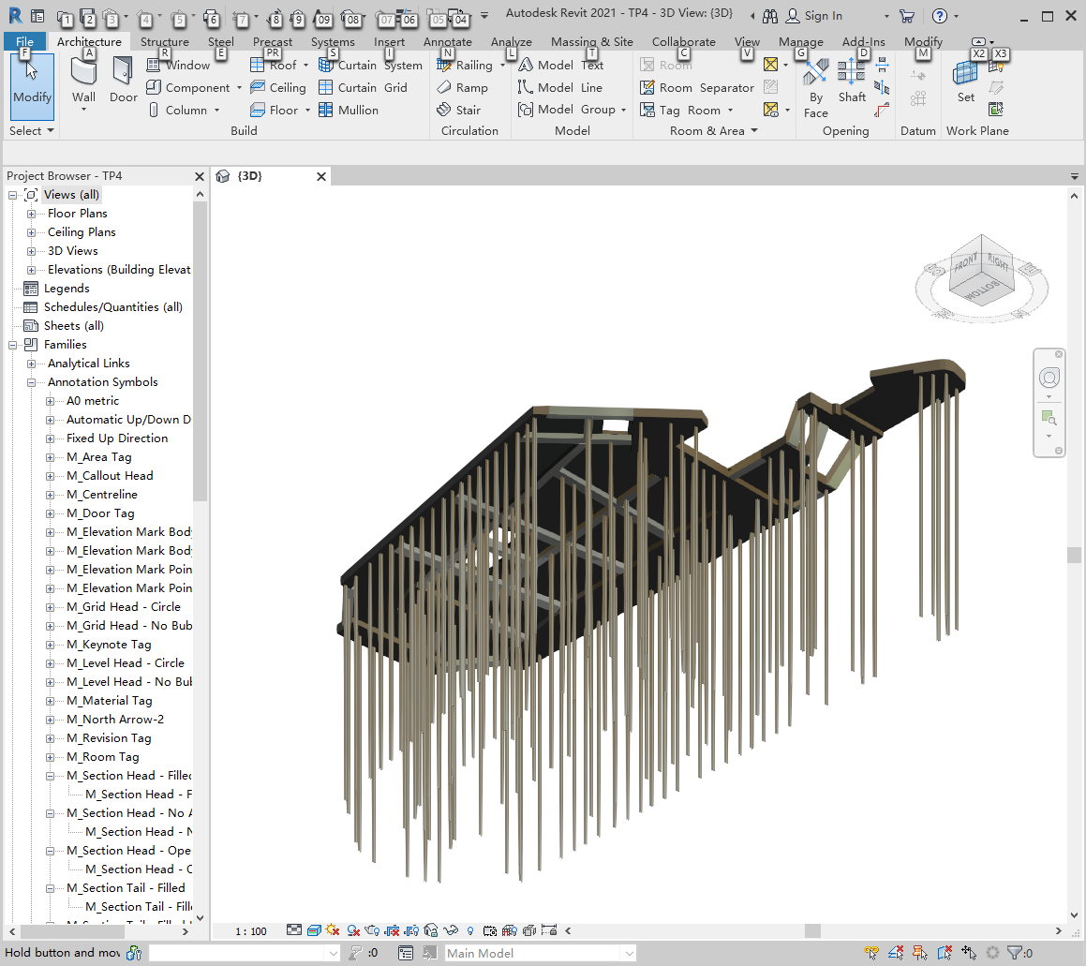

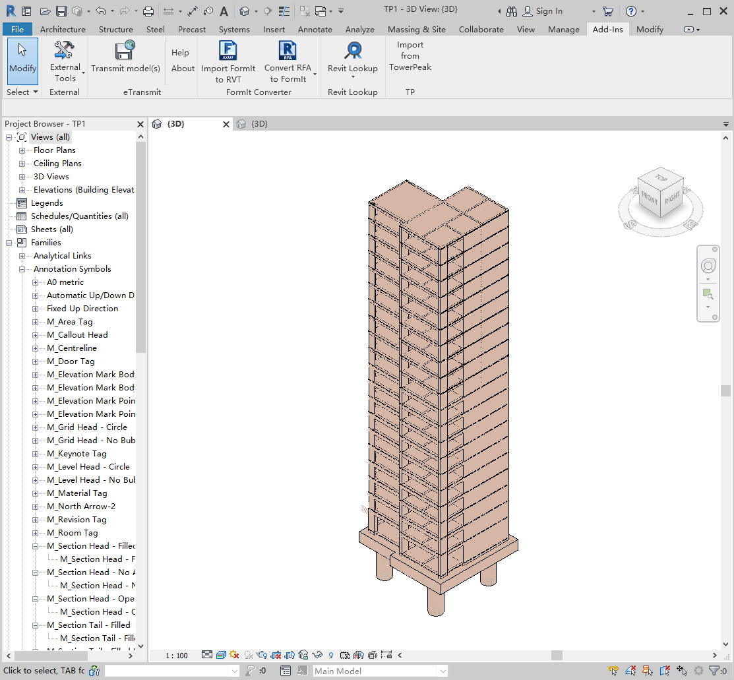

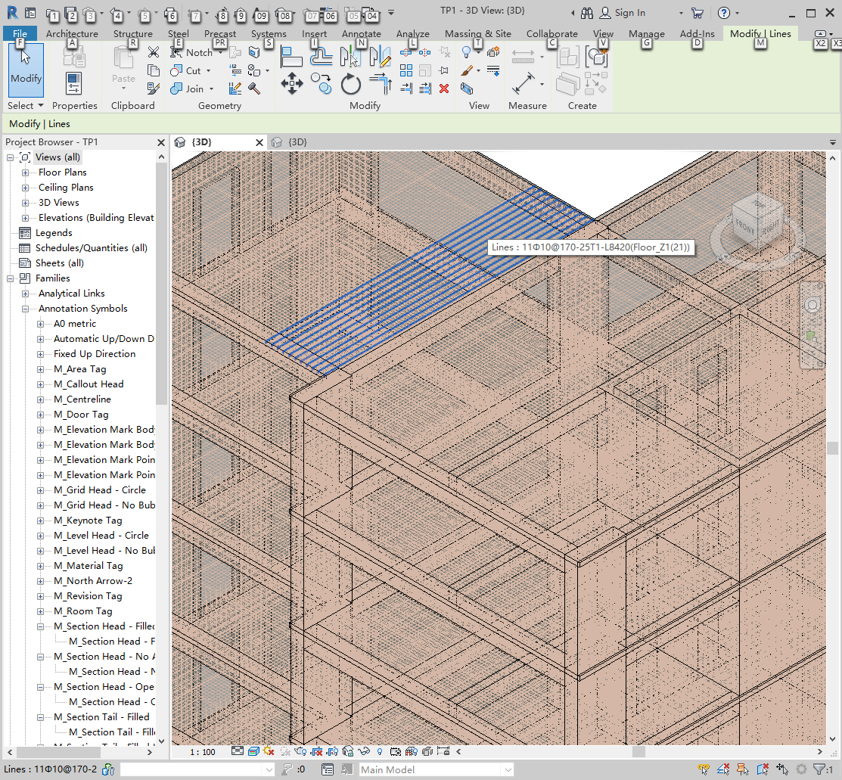

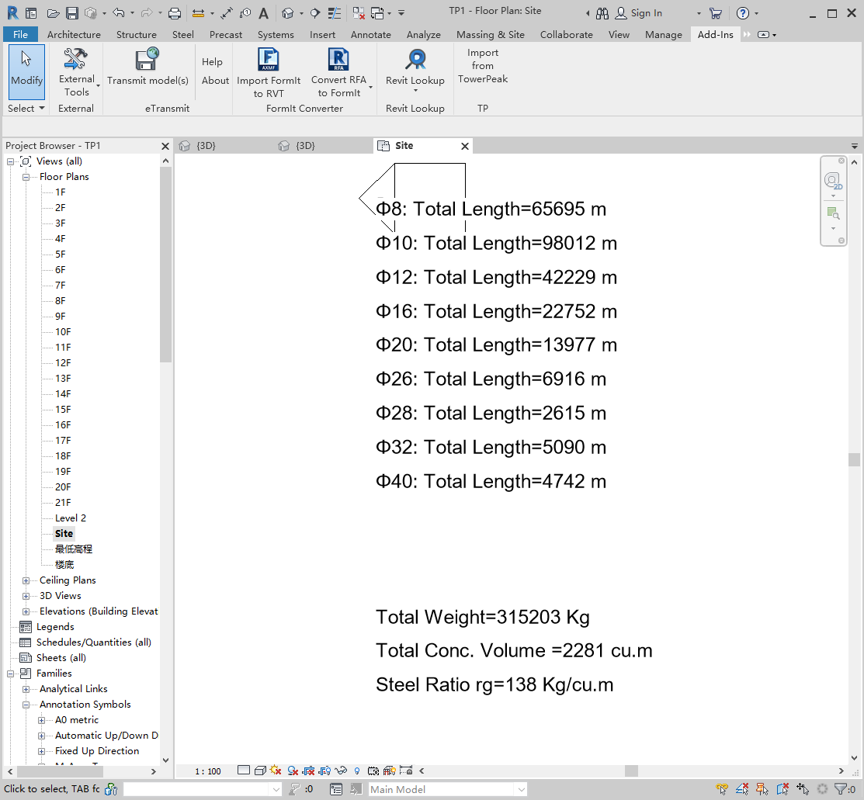

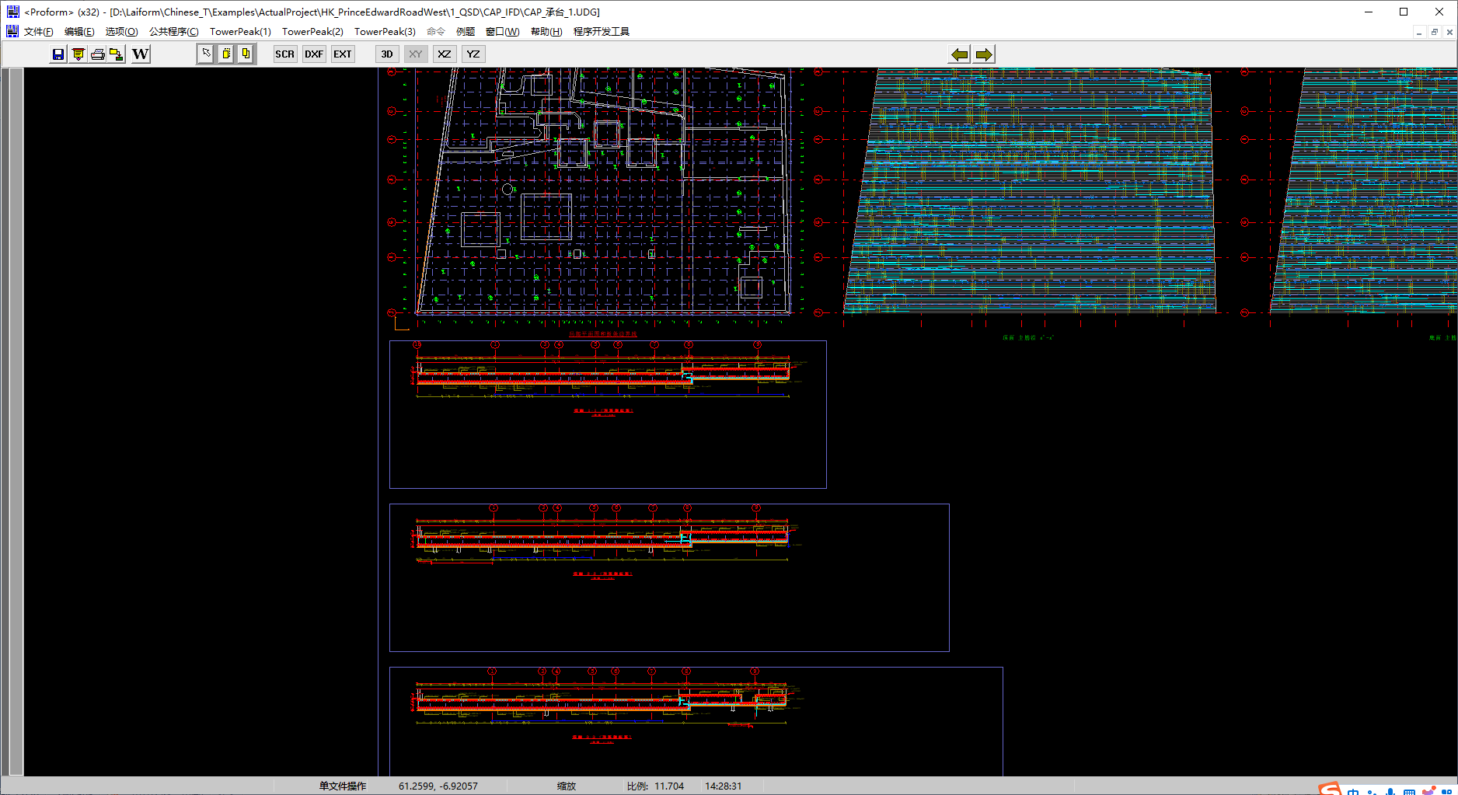

1. The structural model can achieve the following scale：
2. A super high-rise building with a height of 1000m and 300 floors (running for 15 hours on a normal PC).

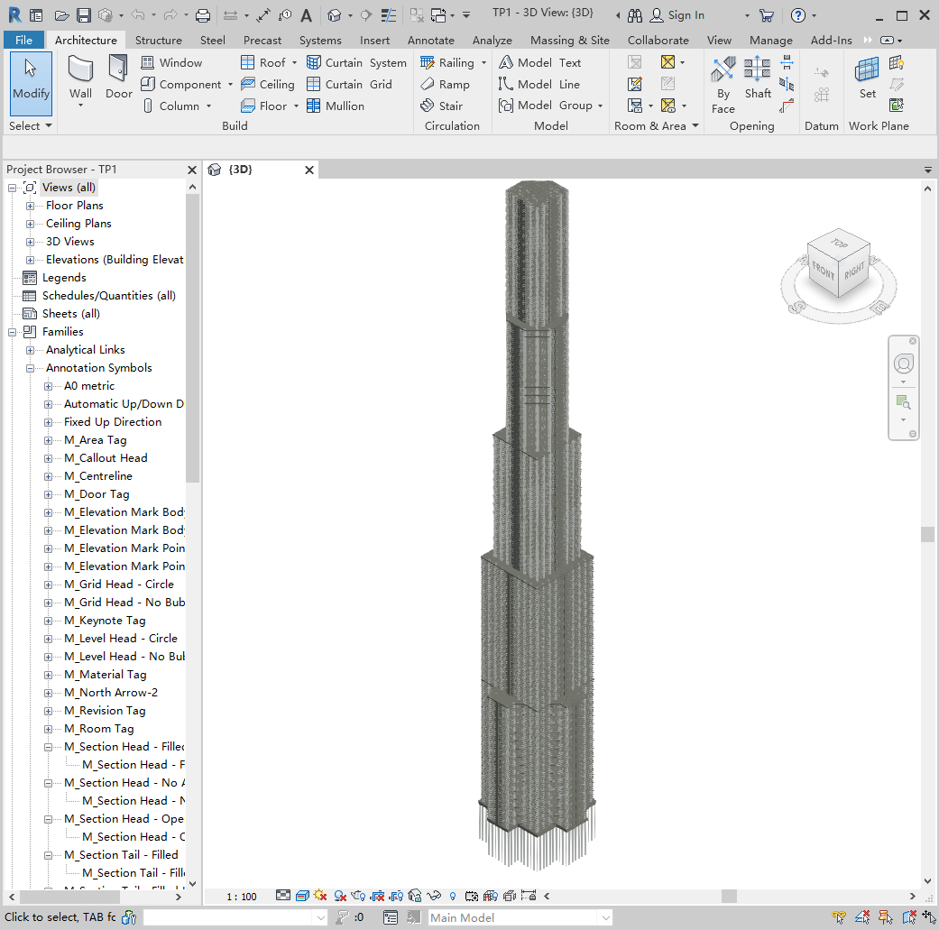

1. 84 story twin tower building (running on a normal PC for 6 hours, followed by elastic-plastic analysis for 4 hours).

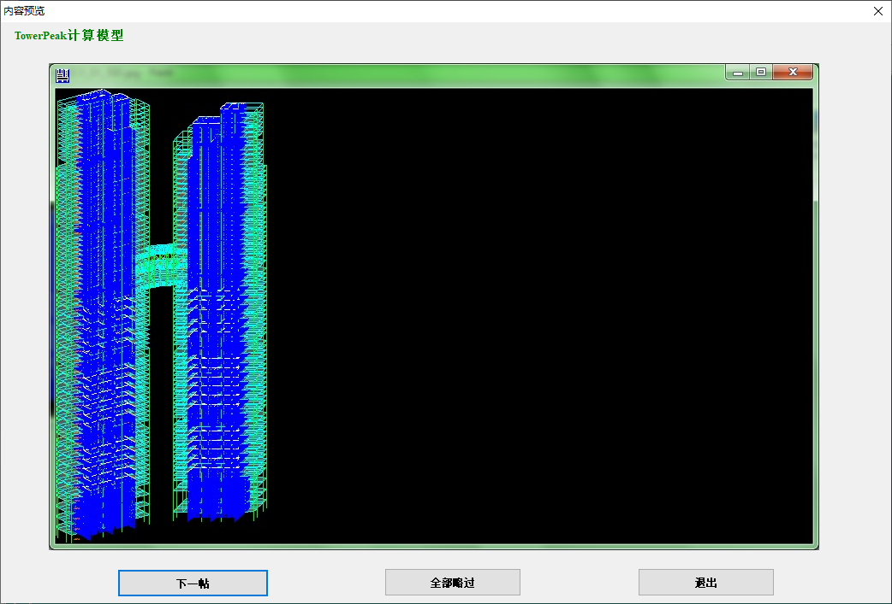

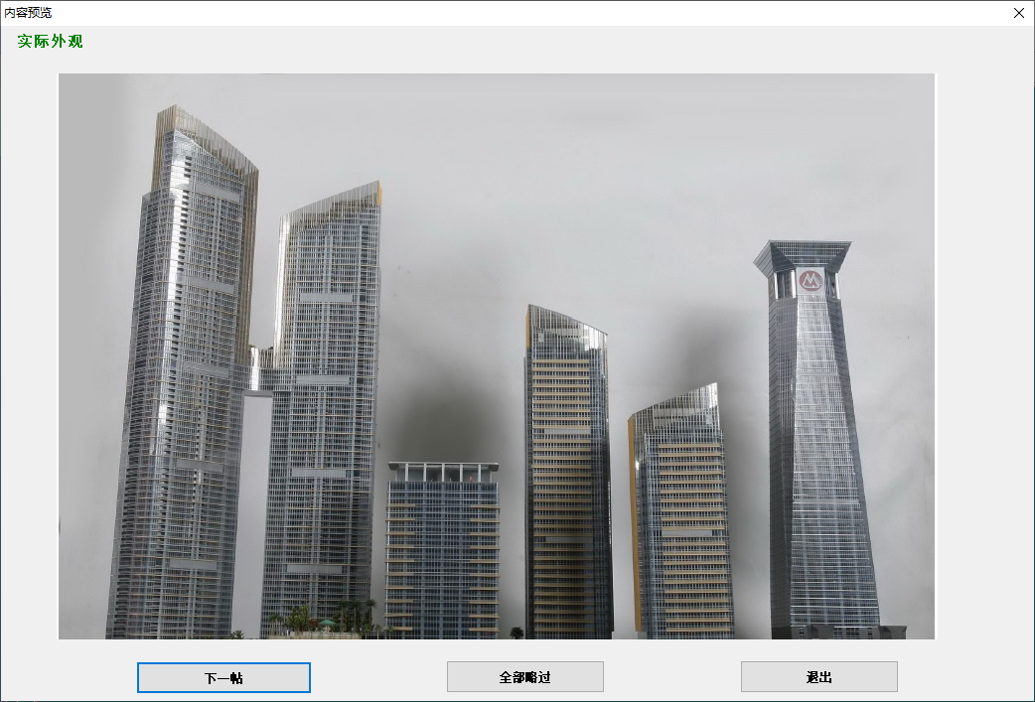

1. A single pile foundation with a plane size of 195m X 107m (running for 3 hours on a normal PC).

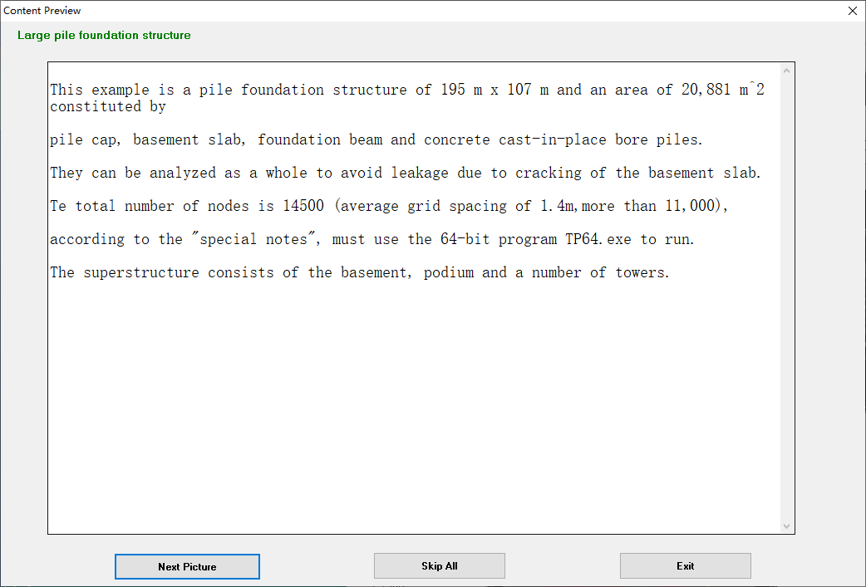

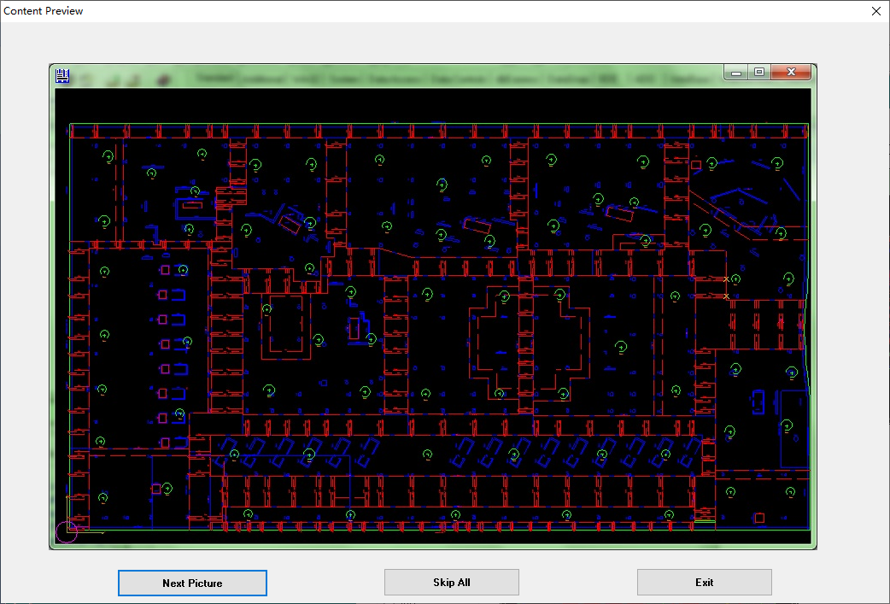

1. A excavation protected project with a plane size of 147m x 10m and deep pit of 17m.

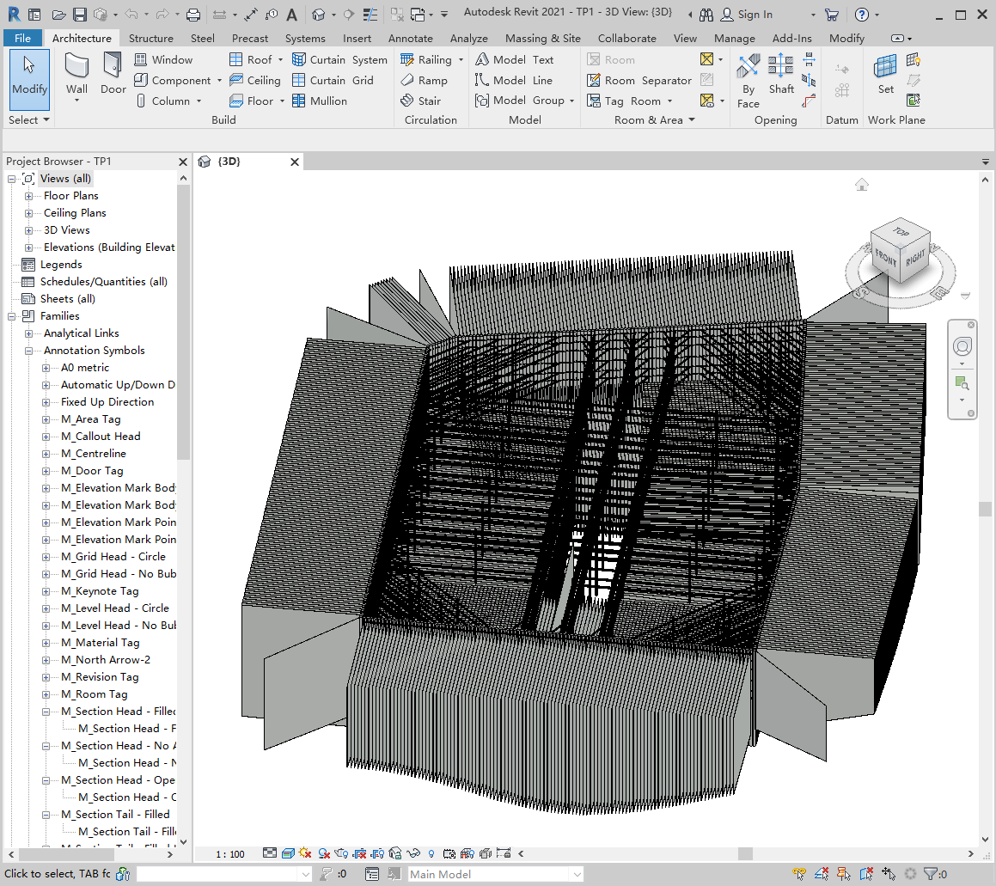

1. Curved pile caps overlie on the slope.

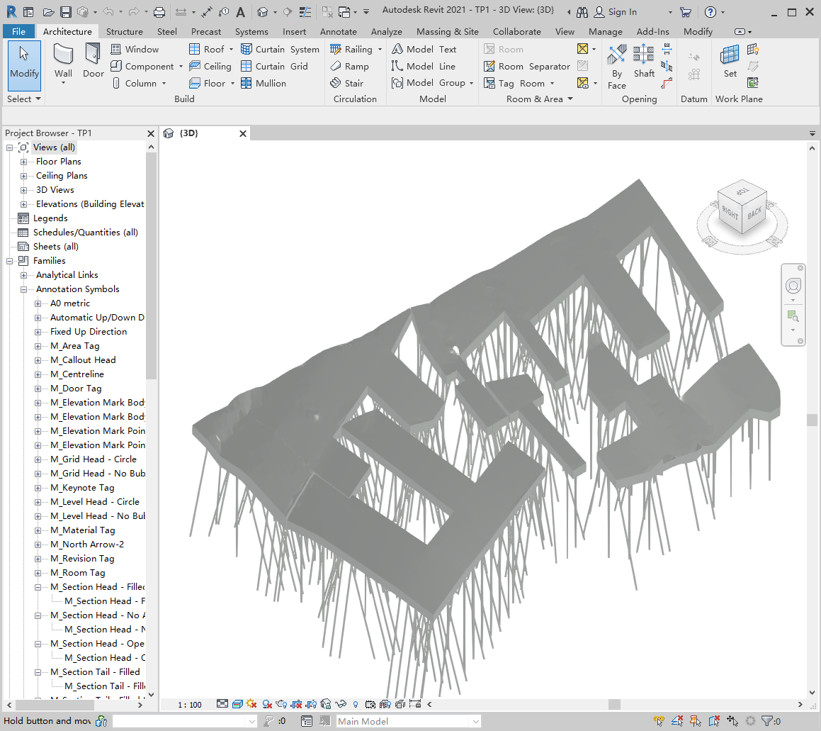

1. Adopted design code adopted

This program adopts the main design coded of China, Hong Kong, the United States, Europe and Australia, and can switch English, simplified Chinese and traditional Chinese at will. For regulations and other languages in other countries and regions, I kindly request colleagues to improve and expand this program based on it.

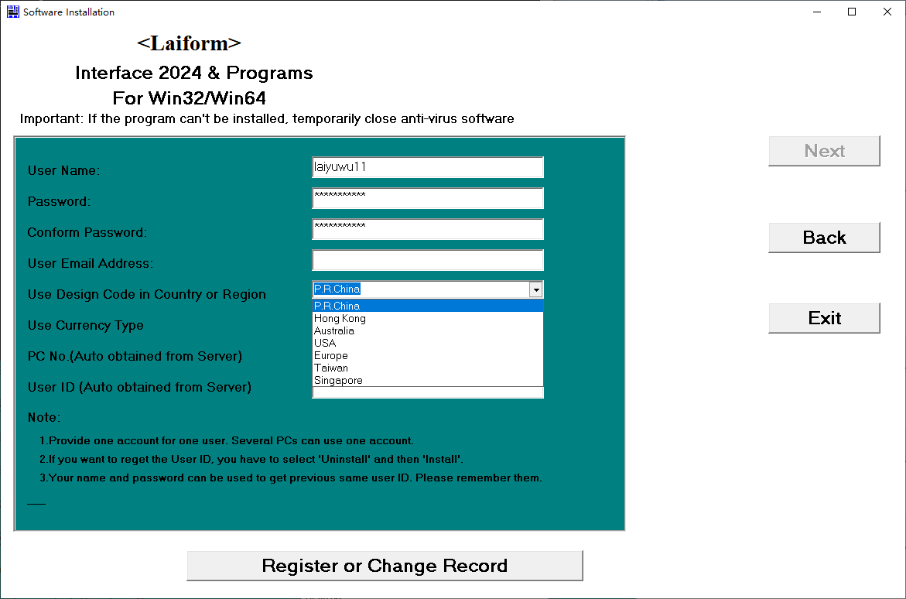

1. This program has been certified by the Hong Kong Buildings Department (registration numbers BD.S0715, S0898, etc.) and the Ministry of Housing and Urban Rural Development of China (Jiankeping [2012] No. 139). After installing the program, these certificates can be found

More detailed instructions can be found on the webpage [www.towerpeak.hk](http://www.towerpeak.hk) or [www.towerpeak.cn](http://www.towerpeak.cn)

Main Developer: Nelson Yuwu Lai

Contact information：

Email：laiformsc@163.com

Wechat ID: Laiyuwu

WhatsApp: +852 93498394